

**SNA NETWORK ADMINISTRATION PROJECT**

**TECHNOLOGY PARK MALAYSIA**

**CT106-3-2-SNA**

**SYSTEM AND NETWORK ADMINISTRATION**

**APU2F2409CS(CYB)**

**DATE ASSIGNED: 7 OCTOBER 2024**

**DATE COMPLETED: 13 DECEMBER 2024**

**GROUP 39**

|  |  |  |
| --- | --- | --- |
| **No.** | **Student Name** | **TP Number** |
|  | **Ng Zhe Shen** | **TP071625** |
|  | **Goh Yuan Kee** | **TP070126** |
|  | **Chloe Tan Jia Xin** | **TP070759** |
| **4.** | **Yee Jie Feng** | **TP070468** |
| **5.** | **Yeo Kok Syen** | **TP071300** |

**LECTURER** **: TS. MANIMEGALAI A/P RAJENDERAN**

**MR. SHAHAB ALIZADEH**

Table of Contents

1.0 Network Configuration 3

1.1 Rocky Server 4

1.2 Ubuntu Client 8

2.0 Network File System (NFS) 10

2.1 Network File System (NFS) Configuration 11

3.0 Apache Web Server 22

3.1 Apache Web Server Configuration 23

4.0 Certificate Authority (CA) 33

5.0 Additional Service 63

6.0 Conclusion 69

7.0 Workload Matrix 70

8.0 References 71

# 1.0 Network Configuration

**DNS Server Verification**

**Explanation of DNS:**

The main function of a DNS server is to translate human-readable domain names into IP addresses that are used to recognize each other on the network. For instance, “www.example.com”. This kind of service is important for network navigation and seamless operation of networked services.

**DNS Configuration:**

In this section, DNS server was correctly setup and verify on the Rocky during individual assignment.

**DHCP Server Verification**

**Explanation of DHCP:**

DHCP server also known as Dynamic Host Configuration Protocol mainly functions to automatically assign IP addresses to the device on the network. This can reduce the administrative load and the risk of manually assigning IP addresses since it has the possibility to cause some issues when manually assigning IP addresses. It also provides additional network configuration details such as subnet masks, default gateways, and DNS server addresses to clients.

**DHCP Configuration:**

In this section, DHCP server was correctly setup and verify on the Rocky during individual assignment.

## 1.1 Rocky Server

Step 1: Use the command **sudo nano /etc/hostname** to open the hostname configuration file.

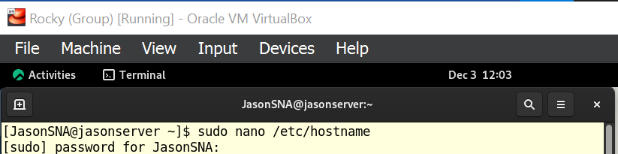

Figure 1.1.1[open hostname configuration file]

Step 2: Write **jasonserver.borgircat.net** to change the hostname inside the hostname configuration file.

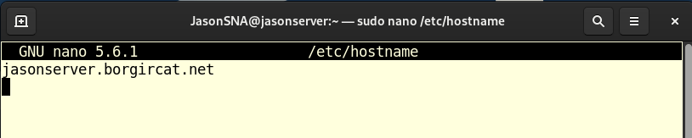

Figure 1.1.2 [inside the sudo nano /etc/hostname]

Step 3: Verify the hostname by using the command **hostname**.

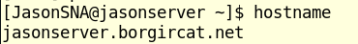

Figure 1.1.3 [verified]

Step 4: Open the DNS forward lookup file using **sudo nano /var/named/fwd.borgircat.net.db**.

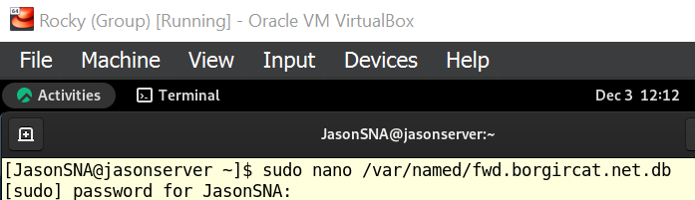

Figure 1.1.4

Step 5: Verify the DNS forward lookup zone file for the domain **borgircat.net**. The IP address **192.168.77.4** is statically assigned to the server **jasonserver,** which the name server for the domain.

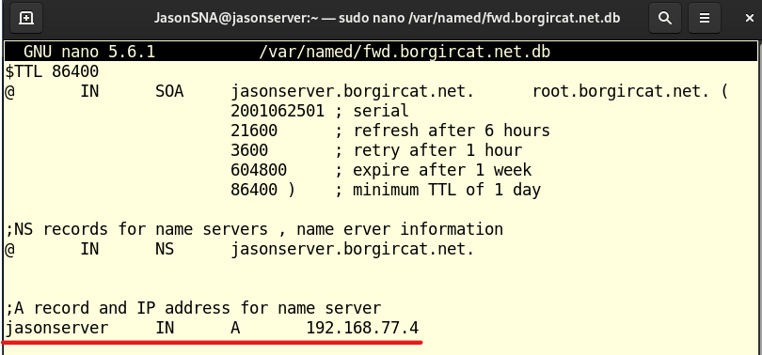

Figure 1.1.5

Step 6: Open the DNS reverse lookup zone file with **sudo nano /var/named/rvs.77.168.192.db**.



Figure 1.1.6

Step 7: Verify the content in the DNS server configuration file:

* **SOA (Start of Authority) Record:**

Defines the primary name server for the domain, administrative contact information, and refresh intervals.

* **NS (Name Server) Record:**

Specifies the name servers responsible for resolving domain names.

* **PTR (Pointer) Record:**

Maps an IP address to a hostname. In this case, it maps the IP address **192.168.77.4** to the hostname **jasonserver.borgircat.net**.

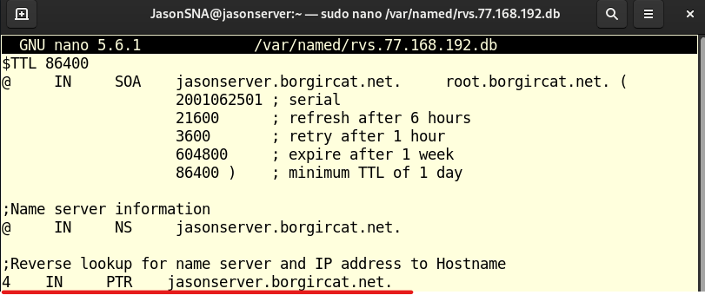

Figure 1.1.7

Step 8: Displays the network interface configuration of the system using the command **ifconfig**. It shows two interfaces:

* **enp0s3:** An Ethernet interface with the IP address **192.168.77.4** assigned to it. This is likely the interface used for communication with the external network.
* **lo:** The loopback interface with the IP address **127.0.0.1.** This interface is used for local communication within the system.

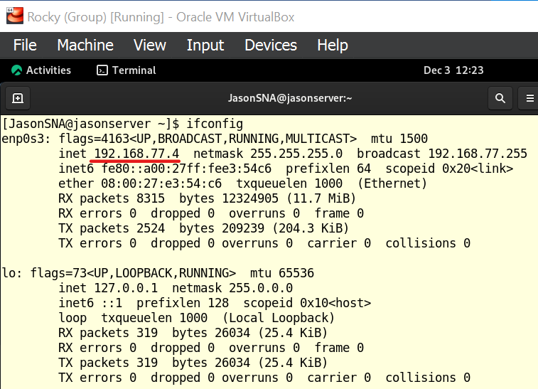

Figure 1.1.8

Step 9: Use the command **nslookup jasonserver.borgircat.net** to verify the DNS working well and correctly.

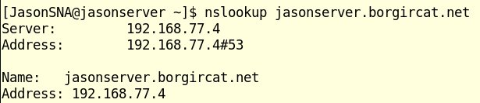

Figure 1.1.9

## 1.2 Ubuntu Client

Step 1: Switch to Ubuntu, use the command **sudo nano /etc/hostname** and open hostname file.

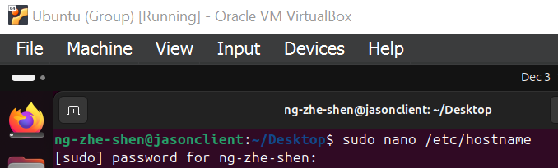

Figure 1.2.1

Step 2: Modify the hostname to **jasonclient.borgircat.net**, save the changes, then exit the nano editor.

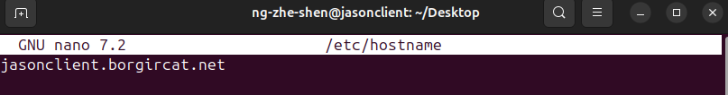

Figure 1.2.2

Step 3: verify the hostname by using the command **hostname**.



Figure 1.2.3[verified]

Step 4: Displays the network interface configuration of the system using the command **ifconfig**. It shows two interfaces:

* **enp0s3:** An Ethernet interface with the IP address **192.168.77.80** assigned to it. This is likely the interface used for communication with the external network.
* **lo:** The loopback interface with the IP address **127.0.0.1.** This interface is used for local communication within the system.

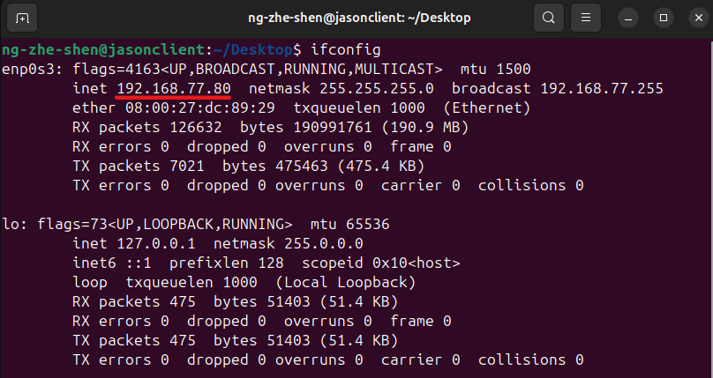

Figure 1.2.4

Step 5: Verify and ensure that the client can communicate with Rocky Server and access network resources, such as the NFS by using the command **ping jasonserver.borgircat.net**.

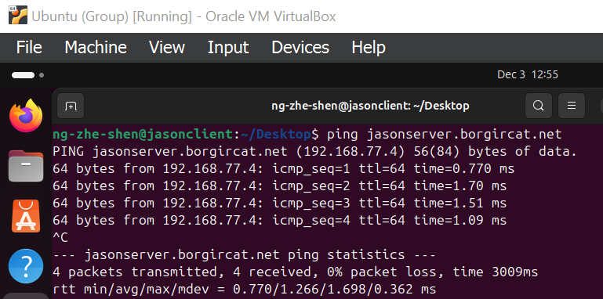

Figure 1.2.5[verified]

# 2.0 Network File System (NFS)

**What is NFS**

Users can browse files on a remote server using this protocol in the same way that they would on their own PCs. Originally developed by Sun Microsystems in the 1980s, it is now a standard feature for network connectivity and file sharing in Linux and UNIX systems. NFS's TCP/IP functionality makes it easy to incorporate remote resources into a local computing environment (GeeksforGeeks, 2023).

**Features and Functions of NFS**

NFS is an essential tool for collaborative situations since it makes file sharing across different devices easier. Transparent file access is one of its advantages, which enables users to work with distant files without changing their apps. Data protection is ensured via NFS's support for secure access techniques, such as export limitations and Kerberos authentication. Interoperability across UNIX, Linux, macOS, and Windows systems is made possible by its cross-platform capabilities, scalability, and suitability for both local networks and big enterprise installations. NFS additionally optimizes performance by using asynchronous writes and caching (Loshin, 2022).

**Conclusion**

In networked workplaces, NFS is a dependable and adaptable protocol that makes file sharing easier and improves teamwork. From personal networks to intricate enterprise infrastructures, its versatility, scalability, and strong features make it an invaluable tool for a variety of use scenarios.

## 2.1 Network File System (NFS) Configuration

Step 1: Install NFS in Rocky Server using the command **sudo dnf install -y nfs-utils**.

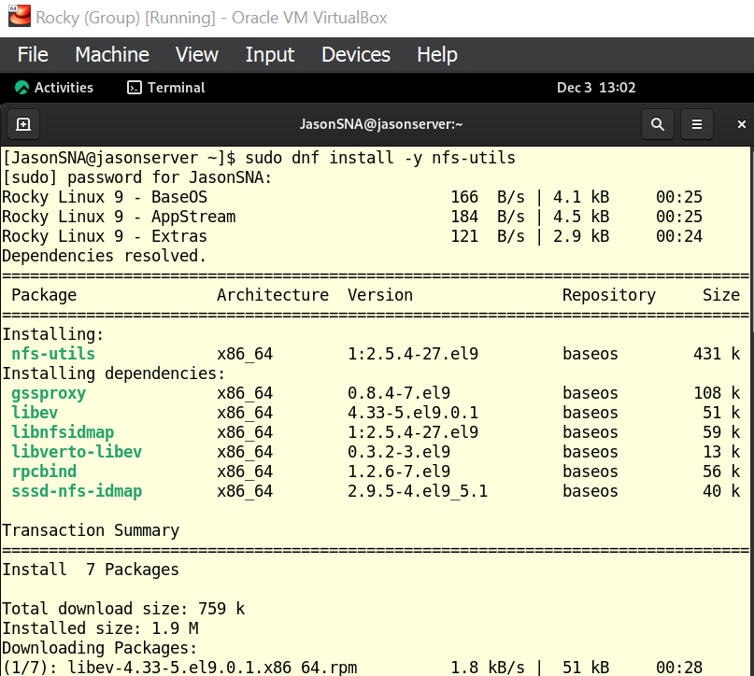  
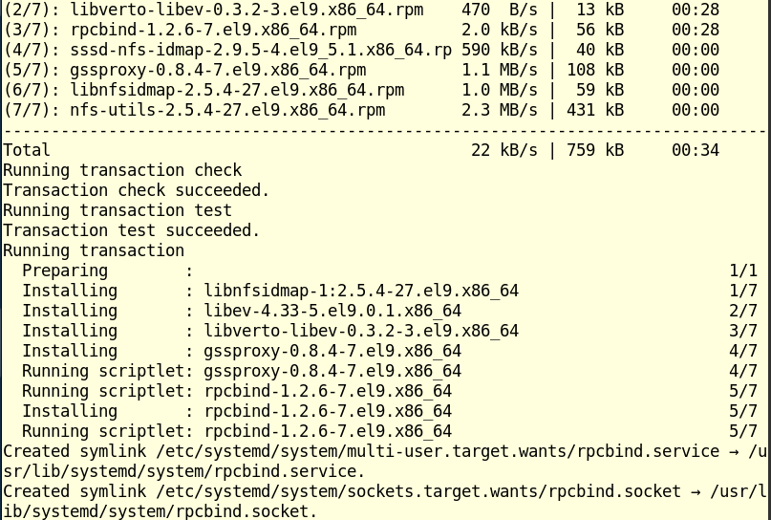  
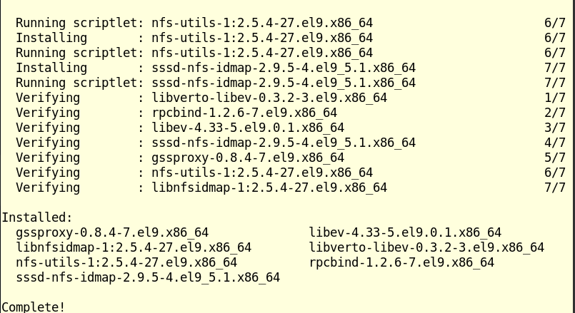

*Figure 2.0.1*

Step 2:Enable and start **nfs-server** using the command **sudo systemctl enable --now nfs-server**.

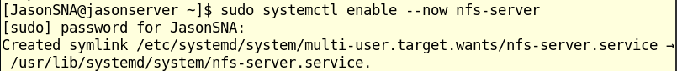

Figure 2.0.2

Step 3: Verify the status of NFS is enabled and active by using the command **sudo systemctl status nfs-server**.

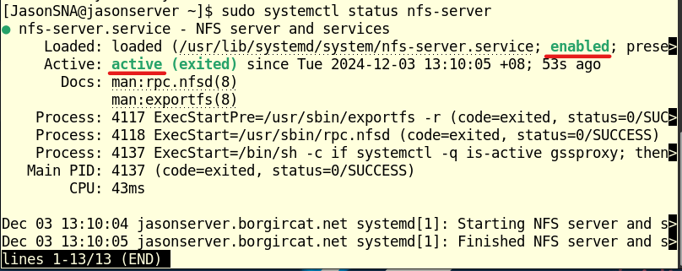

Figure 2.0.3[nfs-server enabled and active(exited)]

Step 4: Create the directory **/var/nfs/ShareToClient** using the command **mkdir**.

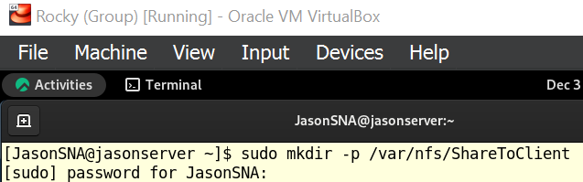

Figure 2.0.4

Step 5: Verifies that the directory was created successfully by using command **ls -ld /var/nfs/ShareToClient/**. The output indicates that the root user and the root group own the directory.



Figure 2.0.5

Step 6: Use the command of **sudo chown nobody:nobody /var/nfs/ShareToClient/**. This command changes the ownership of the directory to the nobody user and the nobody group. This is often done for processes that don’t require specific user association.



Figure 2.0.6

Step 7: Run the command **ls -ld /var/nfs/ShareToClient/** again. The output now shows that the directory is owned by the nobody user and the nobody group.



Figure 2.0.7

Step 8: Open and edit the file by using the command **sudo nano /etc/exports**.

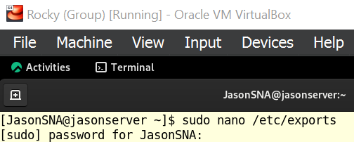

Figure 2.0.8

Step 9: Use the command **/var/nfs/ShareToClient** **197.168.77.80 (rw, sync, no_subtree_check)** and make sure that the export destination is the IP address of Ubuntu Client.

* **rw:** This grants read-write access to the client. The client can read from, modify, and create files within the shared directory /var/nfs/general.
* **sync:** This option ensures that writes from the client are committed to the server's disk immediately. This can be slower but provides data integrity in case of crashes.
* **no_subtree_check**: - this option prevents subtree checking, a process where the host must check whether the file is available along with permissions for every request. It can also cause issues when a file is renamed on the host while still open on the client. Disabling it improves the reliability of NFS.

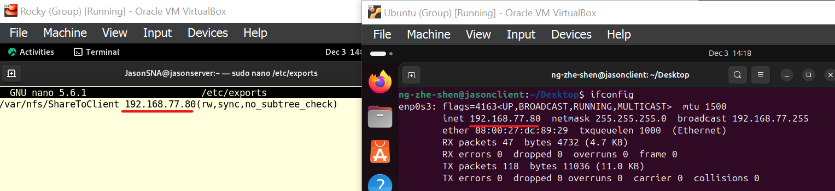

Figure 2.0.9

Step 10: Use the command **sudo exportfs -arv** in Rocky Linux is used to manage and export NFS shares defined in the /etc/exports file.

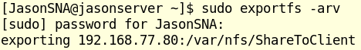

Figure 2.0.10

Step 11: Type in the command as shown in Figure 2.0.13. This is to add all the services under NSF so that it can be allowed by the firewall.

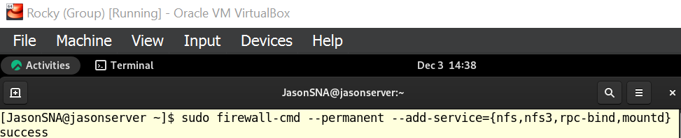

Figure 2.0.11

Step 12: Make sure to reload the firewall settings using the command in Figure 2.0.12 to permanently apply the changes.



Figure 2.0.12

Step 13: To confirm changes have been made, run the command shown in Figure 2.0.15 to restart the NFS services again. The command instructs systemd to reread the configuration files since these files define the available services on the system such as their dependencies, startup behavior, and other settings.



Figure 2.0.13

Step 14: Check the status of the services and make sure it is enabled and active.

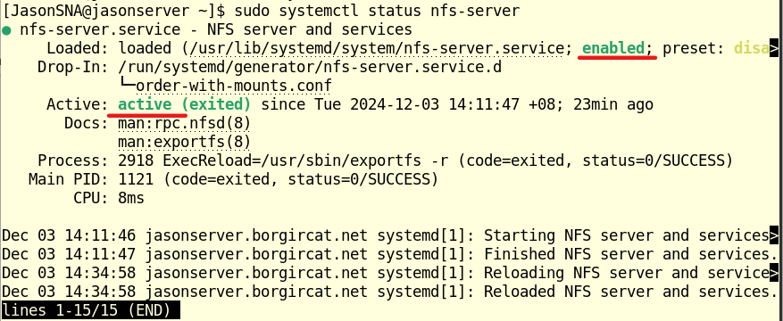

Figure 2.0.14

Step 15: Test if the NFS share is working, create a test file on the server using the command shown in Figure 2.0.17.

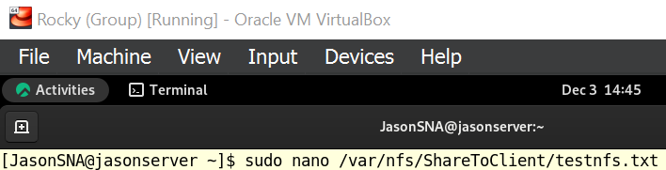

Figure 2.0.15

Step 16: If the file exists and shows content, the NFS configuration and communication between the server and client is successful. The example is shown in Figure 2.0.18.



Figure 2.0.16

Step 17: To install the NFS client, type in the command shown in Figure 2.0.19 and Figure 2.0.20 and wait until it is completed.

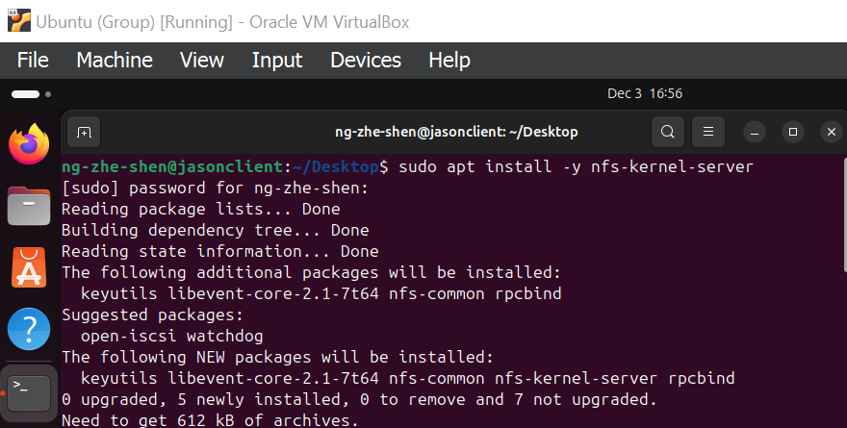

Figure 2.0.17

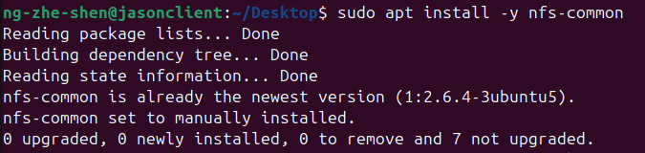

Figure 2.0.18

Step 18: Then, create a directory in the client to permanently mount the shared directory at the server to Ubuntu client shown in Figure 2.0.21. This is to link and attach them together. It is important to note that the command should include **-p** in order to use permanent mounting method.



Figure 2.0.19

Step 19: List the details of the directory made earlier. The output should be as shown in Figure 2.0.22, showing that the directory has been successfully created.



Figure 2.0.20

Step 20: Run the command shown in Figure 2.0.21 to open and edit the file.

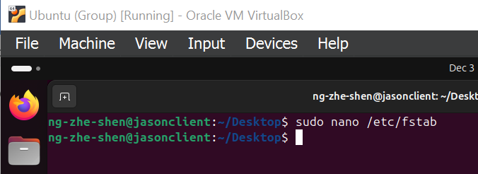

Figure 2.0.21

Step 21: Add the lines shown in Figure 2.0.24 and Figure 2.0.25 to the end of the file. The command to create the directory uses an absolute path to make sure the path is recognized by the system, even during boot processes. Unlike using the "~" symbol, it would fail because system processes such as mounting during boot do not have any information about specific user environments.

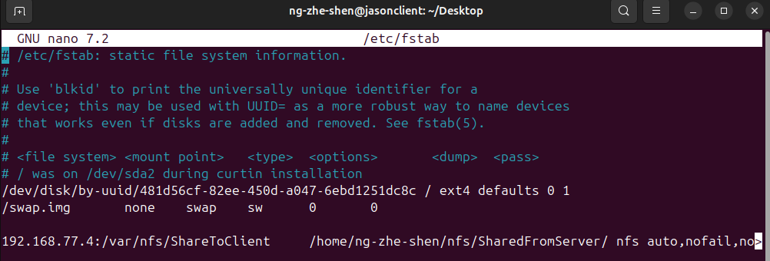

Figure 2.0.22

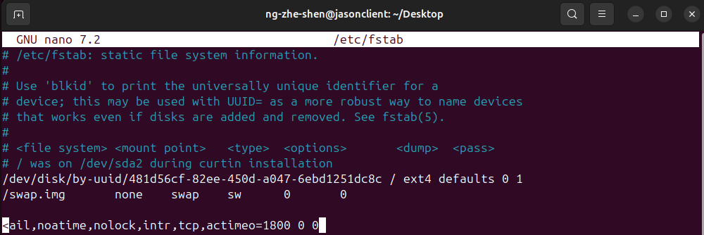

Figure 2.0.23

Step 22: After saving the file, reboot the system.

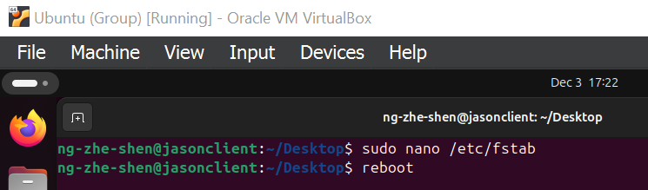

Figure 2.0.24

Step 23: Using the command **df -h**, check if the shared directories are discoverable on the NFS client. The example is shown in Figure 2.0.27.

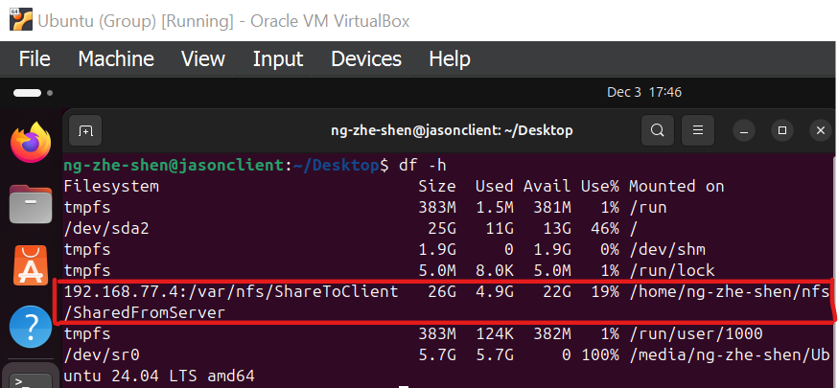

Figure 2.0.25

Step 24: Using the command shown in Figure 2.0.28, we can see all the files in the directory.

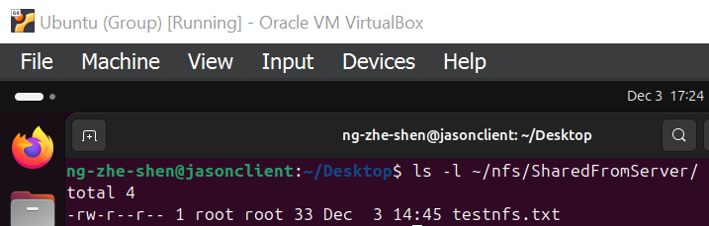

Figure 2.0.26

Step 25: Type in the command shown in Figure 2.0.29, the output should display as shown in the image.



Figure 2.0.27

Step 26: To test the NFS at the Ubuntu Client system, use the command shown in Figure 2.0.30 to create a file.



Figure 2.0.28

Step 27: Using the **ls** command again, check if the file just created appears.

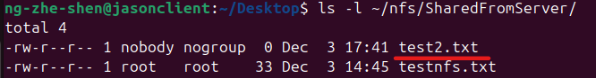

Figure 2.0.29

Step 28: Go back to Rocky server, type in the same command to check if the file is also shared in Rocky server too.

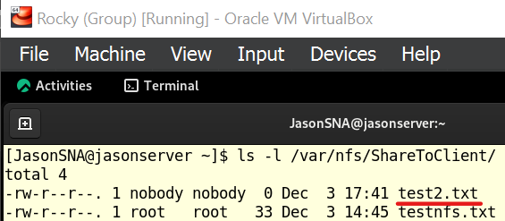

Figure 2.0.30

Step 29: In Ubuntu client, try to make a directory. Type in the command as shown in Figure 2.0.33.

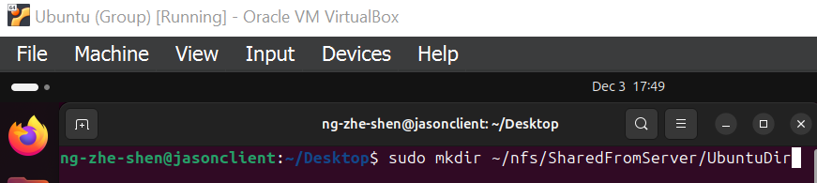

Figure 2.0.31

Step 30: Go back to Rocky server, use the command shown in Figure 2.0.32, the directory just made should appear.

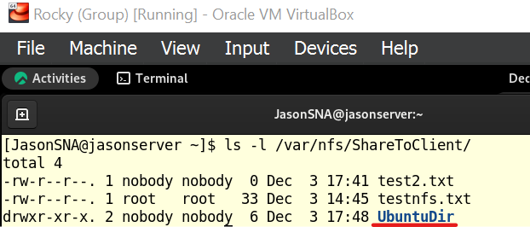

Figure 2.0.32

Step 31: Type in the command shown in Figure 2.0.33 to create and edit the "accessDir.txt" file.



Figure 2.0.33

Step 32: Edit the file as Figure 2.0.34. Save the file by pressing CTRL+X, then Y, and Enter.

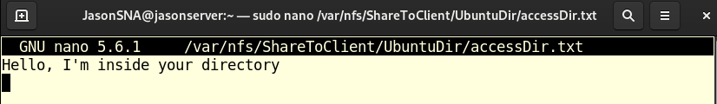

Figure 2.0.34

Step 33: Lastly, go back to Ubuntu client and by using the "cat" command, the output should display the contents in the "accessDir.txt" file. This proves that the NFS setup is working successfully.

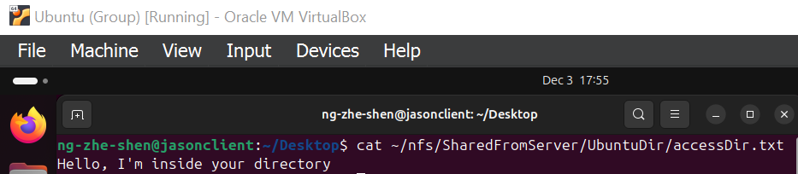

Figure 2.0.35

# 3.0 Apache Web Server

**What is Apache Web Server?**

Apache Web Server is a free and open-source web server used to serve web content over the internet (Hernandez, 2019). It is considered as one of the most popular and reliable web servers in the world (Domantas, 2024). It has been developed and maintained by Apache Software Foundation since it was first released in 1995.

**What Apache Web Server is Used For?**

Apache Web Server is mainly used to host websites. It handles HTTP/HTTPS requests from web clients and deliver the requested web content back in the form of HTML files (Domantas, 2024). Besides that, Apache Web Server also supports virtual hosting such as IP-based and name-based virtual hosts (vhosts) (Apache, n.d.). This enables the system administrator to host multiple websites on a single server.

**Why Apache Web Server?**

Despite the emergence of newer web servers offering better performance, Apache remains a viable option for system administrators due to its comprehensive key features (Hernandez, 2019). According to Domantas (2024), key features of Apache Web Server include:

* Free and open-source
* Reliable
* Easy to set up
* Cross-Platform Compatibility
* Flexible configuration
* Supports SSL/TLS encryption for secure connections

## 3.1 Apache Web Server Configuration

Step 1: In Rocky Server, use the command **sudo dnf install -y httpd** to install Apache web server.

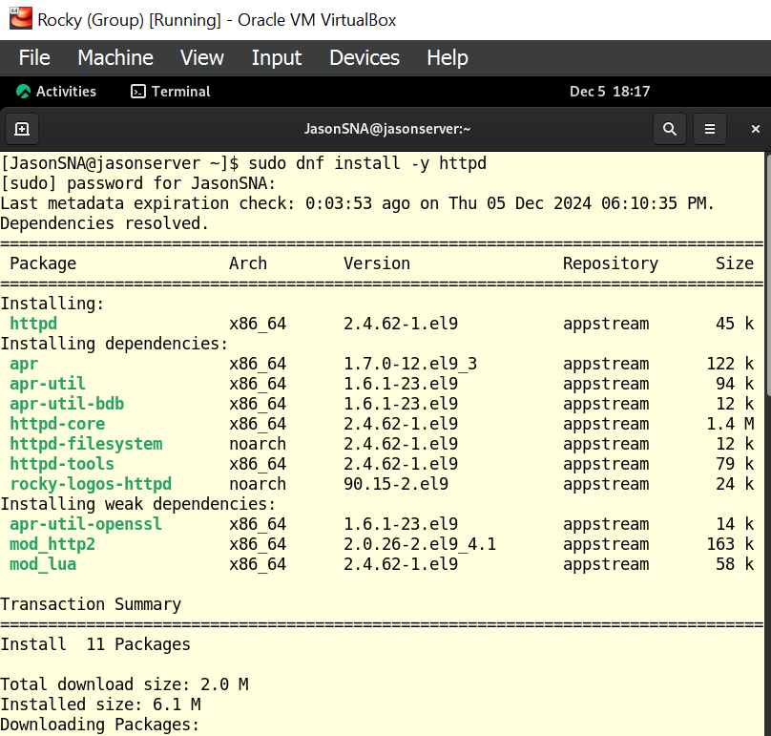  
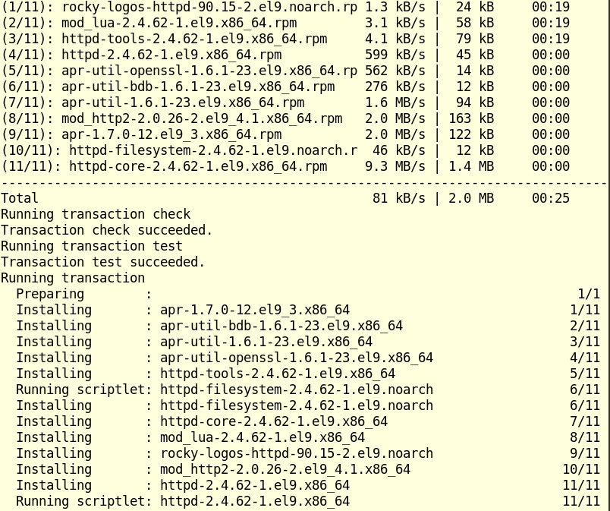  
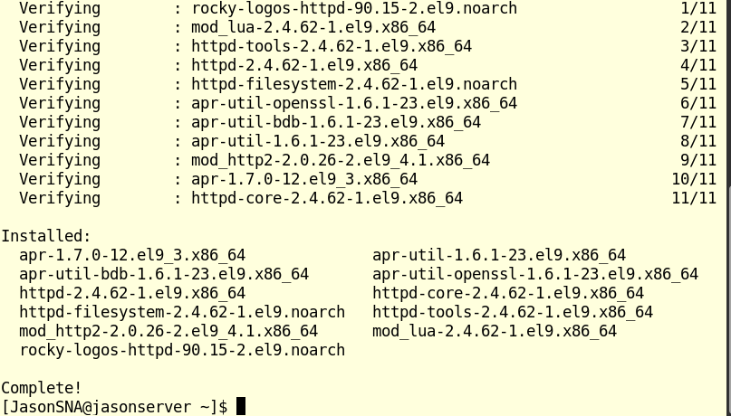

Figure 3.2.1 [Apache Web Server Installation]

Step 2: Use the command **sudo systemctl enable --now httpd** to enable httpd service to start now and whenever the system boots.

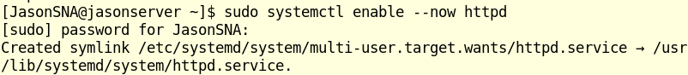

Figure 3.2.2 [Enabling httpd Service]

Step 3: Use **sudo firewall-cmd --permanent --add-service=http** command to open port 80 (HTTP) in the firewall permanently. This is to allow incoming http traffic to pass through the firewall for web services.

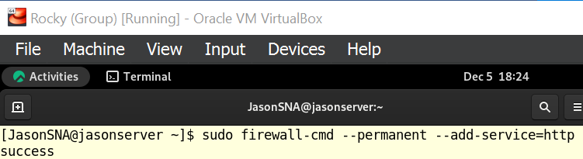

Figure 3.2.3 [Opening Port 80 in the Firewall]

Step 4: Permanently open port 443 (HTTPS) in the firewall by using the command **sudo firewall-cmd --permanent --add-service=https**



Figure 3.2.4 [Opening Port 443 in the Firewall]

Step 5: To apply the changes, reload the firewall by using **sudo firewall-cmd –reload**



Figure 3.2.5 [Reloading Firewall]

Step 6: Use the command **sudo mkdir -p /var/www/group39** to create the website directory to store all the HTML files for the **group39** website.

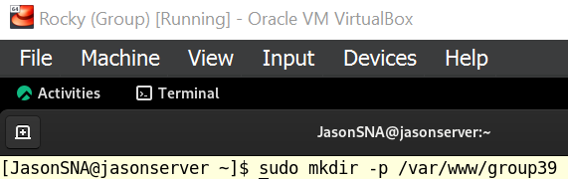

Figure 3.2.6 [Creating Website Directory]

Step 7: Create the file **index.html** under **group39** directory using the command **sudo nano /var/www/group39/index.html**.



Figure 3.2.7 [Creating index.html File]

Step 8: In the file, write some basic HTML script for the homepage.

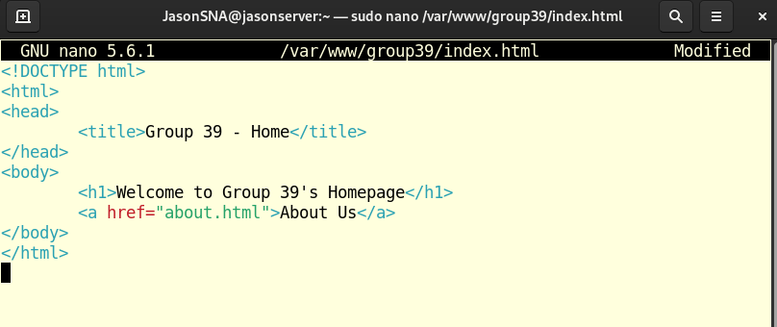

Figure 3.2.8 [Writing HTML Script for Home Page]

Step 9: Similarly, create the second file **about.html** under **group39** directory using the command **sudo nano /var/www/group39/about.html**.



Figure 3.2.9 [Creating about.html File]

Step 10: In the file, write some HTML script for the About Us page.

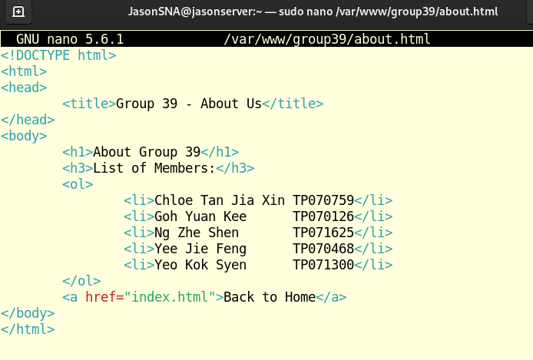

Figure 3.2.10 [Writing HTML Script for About Us Page]

Step 11: Create an Apache virtual host configuration file with the command **sudo nano /etc/httpd/conf.d/group39.com.conf**.

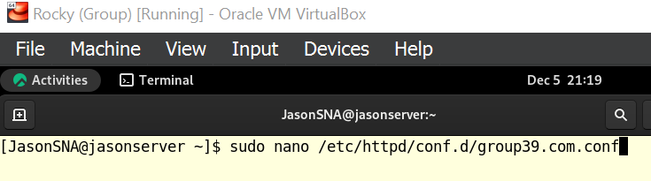

Figure 3.2.11 [Creating Apache Virtual Host Configuration File]

Step 12: In the Apache virtual host configuration file, write the following lines to host the web application for **www.group39.com**.

**<VirtualHost *:80>**: Creates a new Apache virtual host and enables Apache to listen for incoming connections on the HTTP port 80.

**ServerName www.group39.com**: Sets “www.group39.com” as the virtual host’s primary domain name.

**ServerAlias group39.com**: Sets “group39.com” as an additional domain name (alias) for the virtual host. This enables clients to access the same website although they did not enter the exact ServerName in their browser.

**DocumentRoot /var/www/group39**: Specifies “/var/www/group39” as the root directory for the virtual host. Apache will look for HTML files in this directory and serve it to the clients.

**ErrorLog /var/log/httpd/group39-error.log**: Sets “/var/log/httpd/group39-error.log” as the error log file for this virtual host. All error messages generated by Apache for this virtual host will be logged in this log file.

**CustomLog /var/log/httpd/group39-access.log combined**: Sets “/var/log/httpd/group39-access.log” as the access log file for this virtual host. The “combined” format includes information about the client, request, server, and response for each log.

**</VirtualHost>**: Marks the end of the virtual host block.

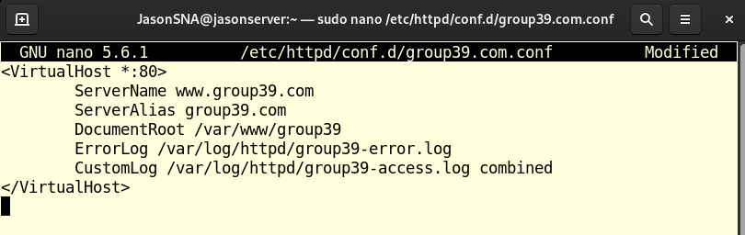

Figure 3.2.12 [Configuring Apache Virtual Host]

Step 13: Check the syntax and validity of Apache’s configuration files by using the command **sudo apachectl configtest**.

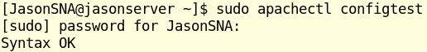

Figure 3.2.13 [Checking Apache’s Configuration Files]

Step 14: Reload Apache to apply changes.



Figure 3.2.14 [Reloading Apache]

Step 15: Open “/etc/hosts” file using nano text editor.

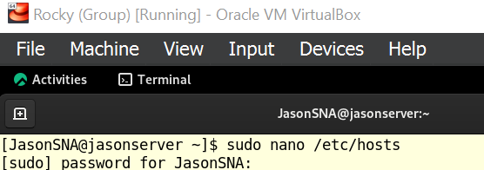

Figure 3.2.15 [Opening “/etc/hosts" File]

Step 16: In the file, add a local DNS entry for the domain **www.group39.com** and map it to the loopback IP address **127.0.0.1**.

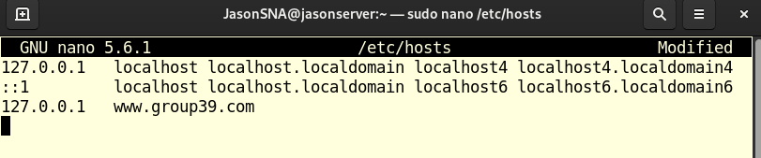

Figure 3.2.16 [Adding Local DNS Entry]

Step 17: Click on the **Activities** button at the top-left corner of the screen and open **Mozilla Firefox** web browser.

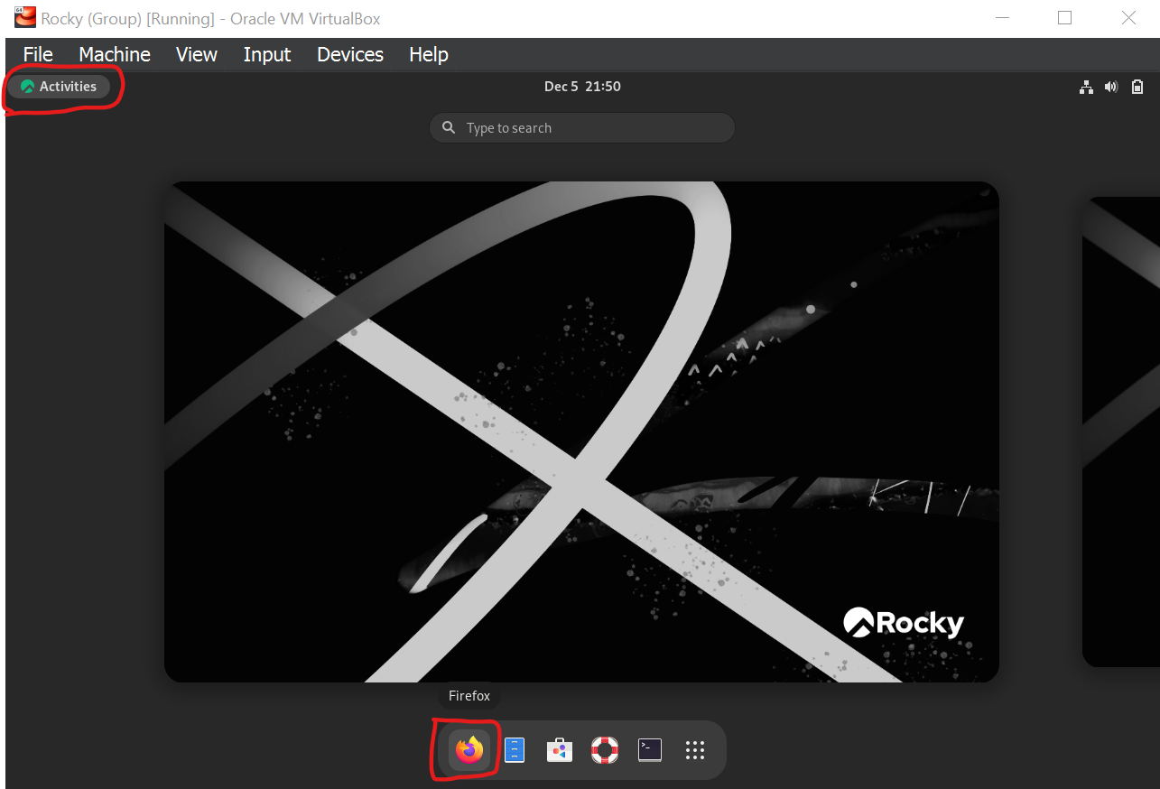

Figure 3.2.17 [Opening Mozilla Firefox Browser]

Step 18: Go to **www.group39.com** to see if the website is being hosted successfully.

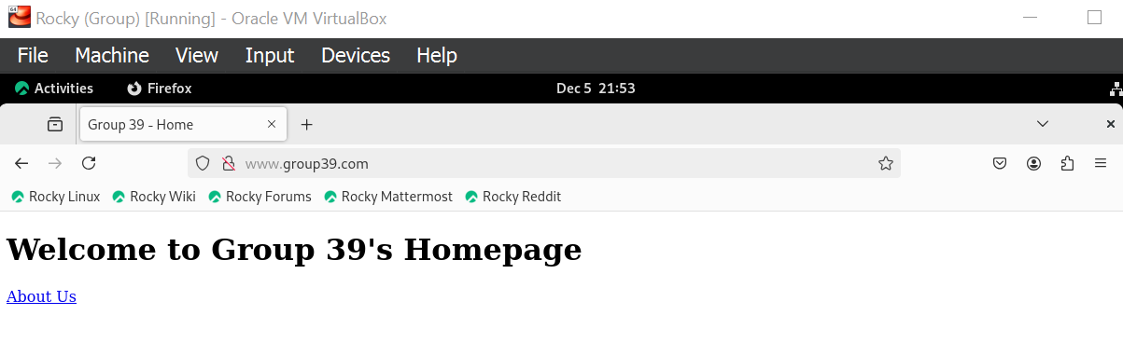

Figure 3.2.18 [Connecting to “www.group39.com”]

Step 19: Click on the **About Us** link to see whether the corresponding webpage will be displayed.

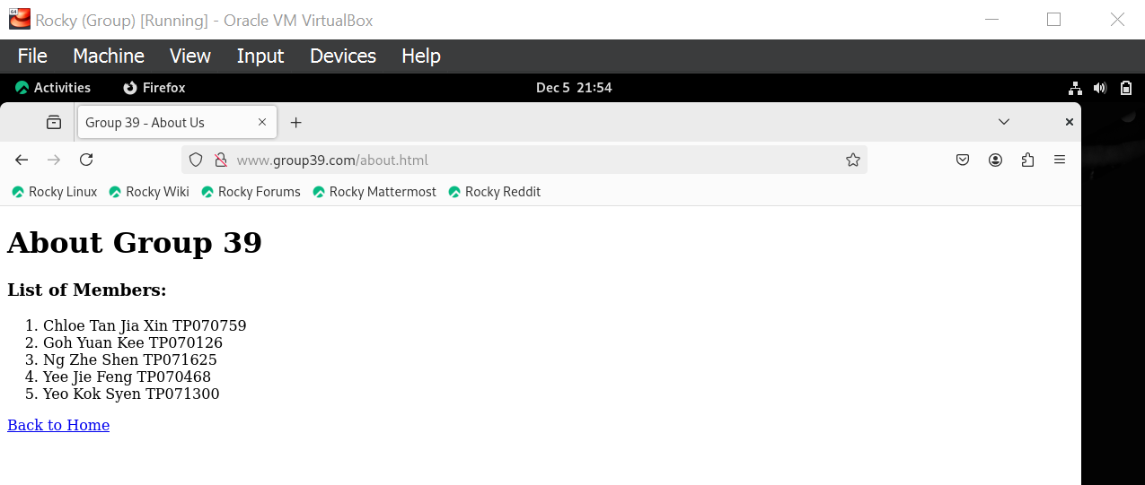

Figure 3.2.19 [After Clicking About Us Link]

Both Figure 3.2.18 and 3.2.19 prove that Apache web server has been configured correctly and the multipage website is accessible by Rocky Server.

Step 20: To make the websiteaccessible by Ubuntu Client as well, boot up Ubuntu Client and modify the hosts file using the command **sudo nano /etc/hosts**.

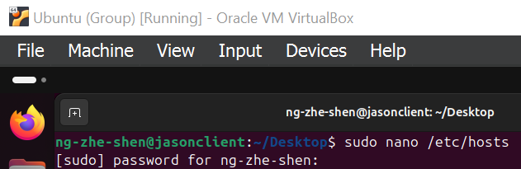

Figure 3.2.20 [Opening “/etc/hosts” Configuration File in Ubuntu]

Step 21: In the file, add the entry for **www.group39.com** and map it to the IP address of Rocky Server.

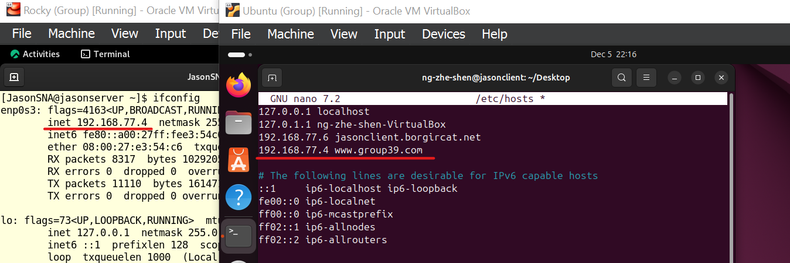

Figure 3.2.21 [Adding entry for “www.group39.com” in Ubuntu]

Step 22: Open **Mozilla Firefox** web browser.

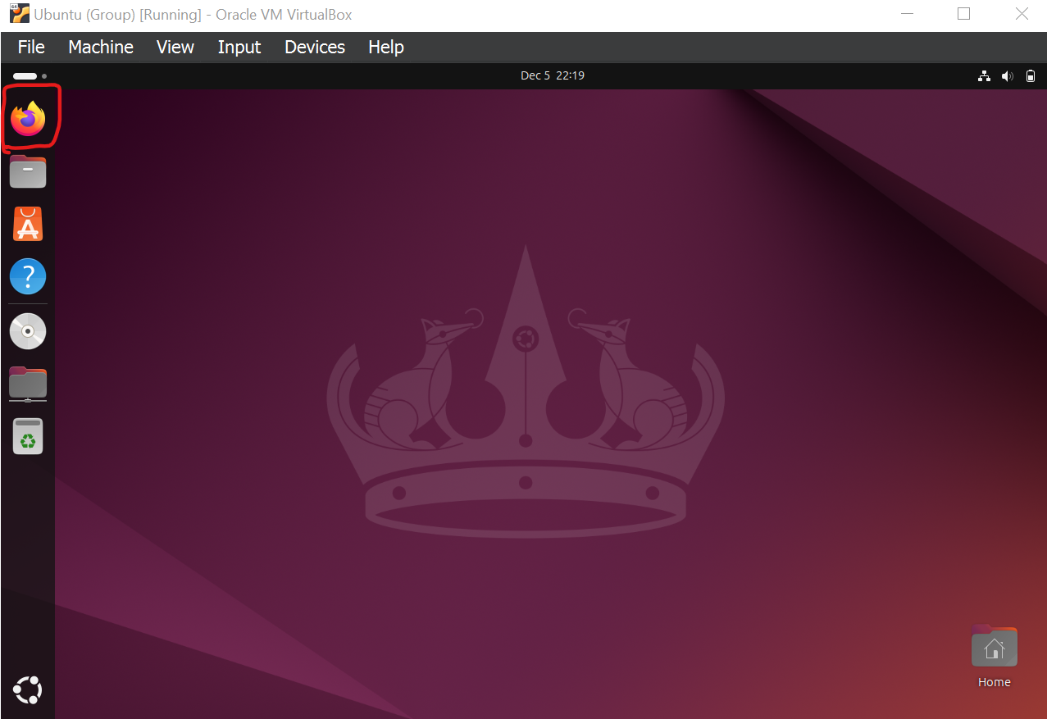

Figure 3.2.22 [Opening Mozilla Firefox Browser]

Step 23: Go to **www.group39.com** to verify if it is accessible by Ubuntu Client.

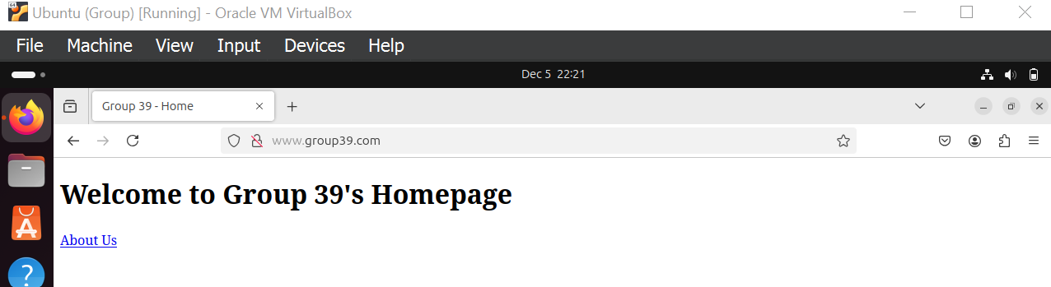

Figure 3.2.23 [Connecting to “www.group39.com”]

Step 24: Click on the **About Us** link to test the accessibility of the **About Us** page for Ubuntu Client.

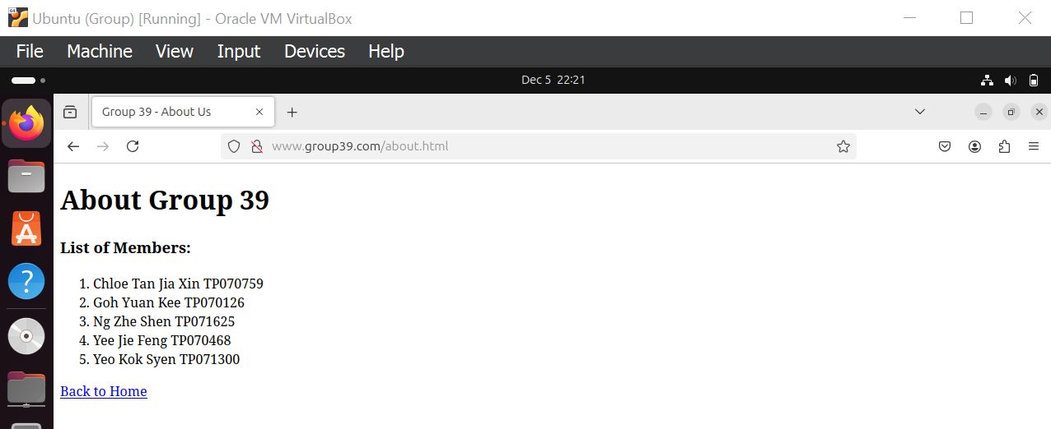

Figure 3.2.24 [After Clicking About Us Link]

Based on the output in Figure 3.2.23 and 3.2.24, it is evident that **www.group39.com** hosted by Apache web server in Rocky Server is accessible by Ubuntu Client as well.

# 4.0 Certificate Authority (CA)

As of now, the website **www.group39.com** is hosted using HTTP protocol (indicated by crossed-out padlock icon), which does not support secured connections or encrypted data transactions. When server and client are communicating without encryption, malicious parties can intercept or alter the data being transmitted. This is called a Man-in-the-Middle (MITM) attack. To enforce the security of the website and prevent such threats, HTTPS must be implemented using a trusted Certificate Authority (CA).

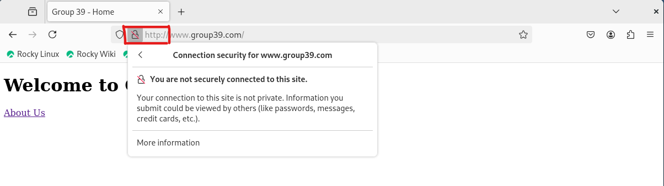

Figure 4.0.1 [Connection is not secured]

Step 1: In Rocky Server, install OpenSSL using the command **sudo dnf install -y openssl** if it is not installed by default already.

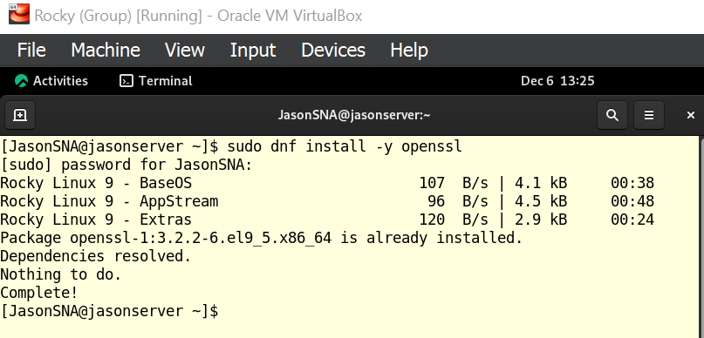

Figure 4.0.2 [Installing OpenSSL]

Step 2: Prepare Public Key Infrastructure (PKI) directories. The first directory is **certs**, which will store CA’s own public certificate. Use the command **sudo mkdir -p /root/CA/certs/**.



Figure 4.0.3 [Making directory for certificates]

Step 3: Similarly, use the command **sudo mkdir -p /root/CA/private/** to create a directory called **private** to store CA’s private key.



Figure 4.0.4 [Making directory for private key]

Step 4: Remove excessive permissions for the **/root/CA/private/** directory with **sudo chmod 700 /root/CA/private/** because the private key that will be generated in the next step must be kept secure.



Figure 4.0.5 [Changing permissions for private key directory]

Step 5: Generate a private key for CA using the command **sudo openssl genrsa /root/CA/private/ca.key 4096**.

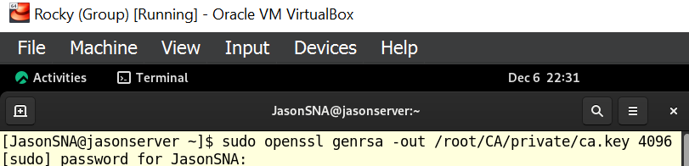

Figure 4.0.6 [Generating private key for CA]

Explanation of command in Figure 4.0.6:

* **openssl**
  + Accesses the OpenSSL toolkit which has tools for managing SSL/TLS keys, certificates and other cryptographic tasks.
* **genrsa**
  + Generates a Rivest-Shamir-Adleman (RSA) private key.
  + RSA is a widely used public-key cryptographic algorithm.
* **-out /root/CA/private/ca.key**
  + Specifies the file path and file for the generated RSA private key.
  + In this case, the private key is **ca.key** in the directory **/root/CA/private/** which was created in step 3.
* **4096**
  + Specifies the size of the key in bits.
  + 4096-bit RSA key is a secure key with a strong encryption that is resistant to brute-force attacks.
  + Suitable for long-term use.

Step 6: Create a self-signed certificate for the CA using the command **sudo openssl req -x509 -new -key /root/CA/private/ca.key -sha256 -days 3650 -out /root/CA/certs/ca.crt**.

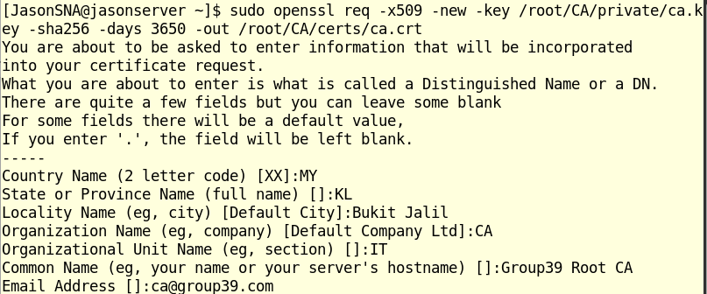

Figure 4.0.7 [Creating self-signed certificate for CA]

* **req**
  + Generates certificate signing requests (CSR) and other certificates.
* **-x509**
* Creates a self-signed certificate instead of a CSR that is selected by default.
* **-new**
* Creates a new certificate.
* **-key /root/CA/private/ca.key**
* Specifies the private key that will be used to sign the certificate.
* The key **ca.key** was created earlier in step 5.
* **-sha256**
* Specifies that SHA-256 hashing algorithm is used to sign the certificate.
* SHA-256 being a secure hash function that is widely used for encryption.
* **-days 3650**
* Specifies the duration in days of the certificate’s validity.
* In this case, 3650 days being 10 years.
* **-out /root/CA/certs/ca.crt**
* Specifies the file path and file that the self-signed certificate will be saved.
* In this case, the certificate is saved as ‘ca.crt’ in the directory **/root/CA/certs/** which was created in step 2.

Step 7: Copy the CA’s self-signed certificate to the NFS shared directory using the command **sudo cp /root/CA/certs/ca.crt /var/nfs/ShareToClient/** so that Ubuntu Client can import it to its Mozilla Firefox web browser as well.

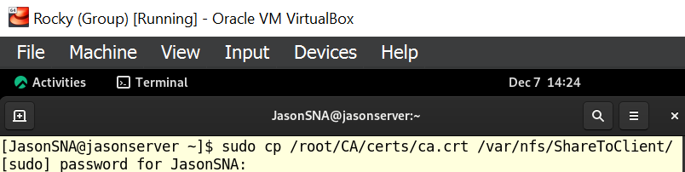

Figure 4.0.8 [Copy created certificate to NFS shared directory]

Step 8: Open **Mozilla Firefox** in Ubuntu Client found in **Activities**.

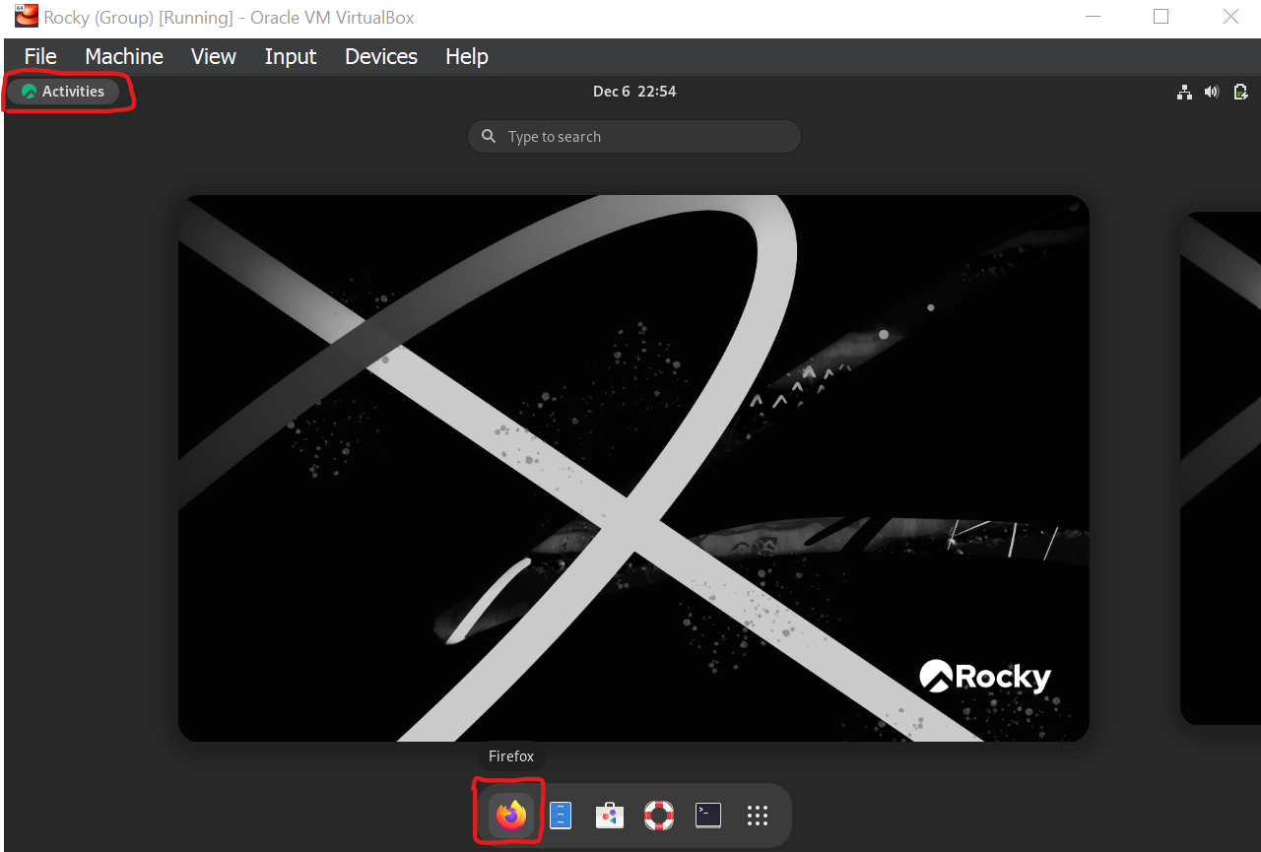

Figure 4.0.9 [Opening Mozilla Firefox in Rocky Server]

Step 9: Open **application menu** (3 horizontal-line icon) at the top right of the web browser.

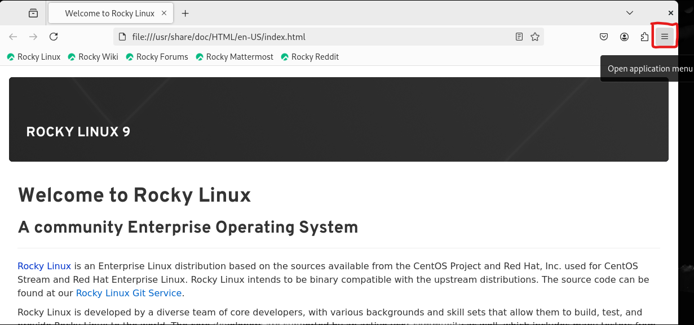

Figure 4.0.10 [Opening application menu]

Step 10: Navigate to **Settings**.

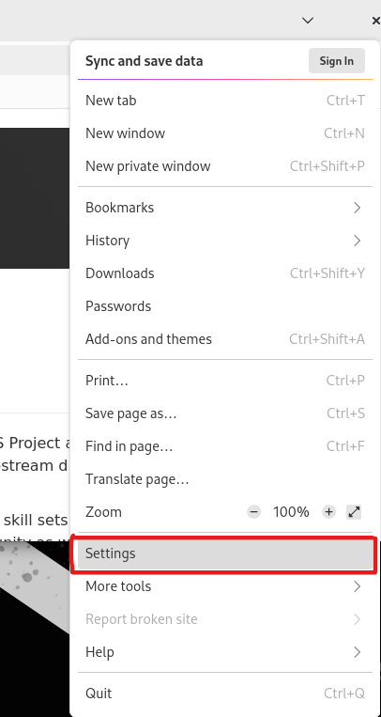

Figure 4.0.11 [Navigating to settings]

Step 11: Go to **Privacy & Security** tab on the left and scroll down to **Certificates** section. Then, click on **View Certificates…** button.

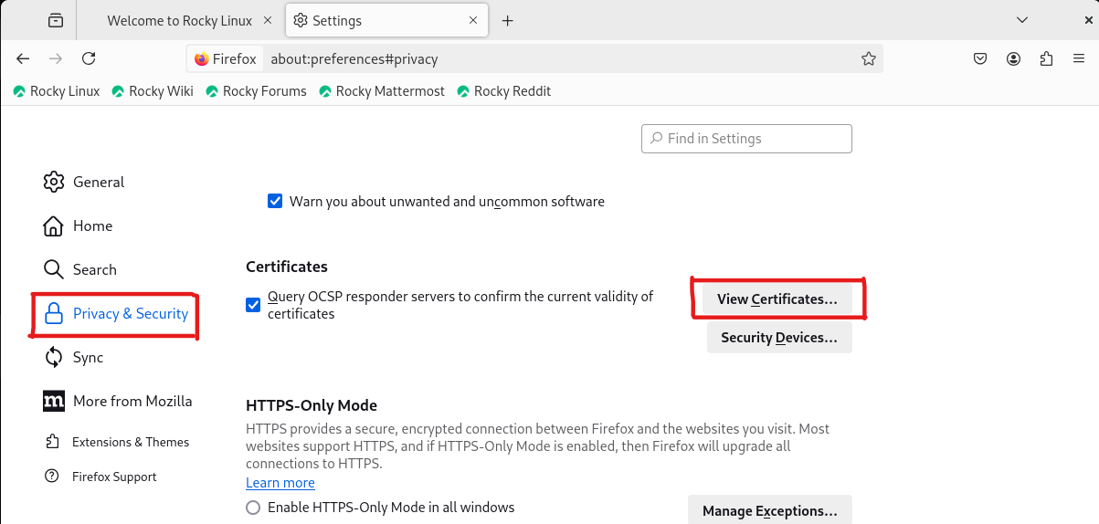

Figure 4.0.12 [Navigating to Certificate Manager]

Step 12: When in the **Certificate Manager**, navigate to **Authorities** tab and click on **Import…** button.

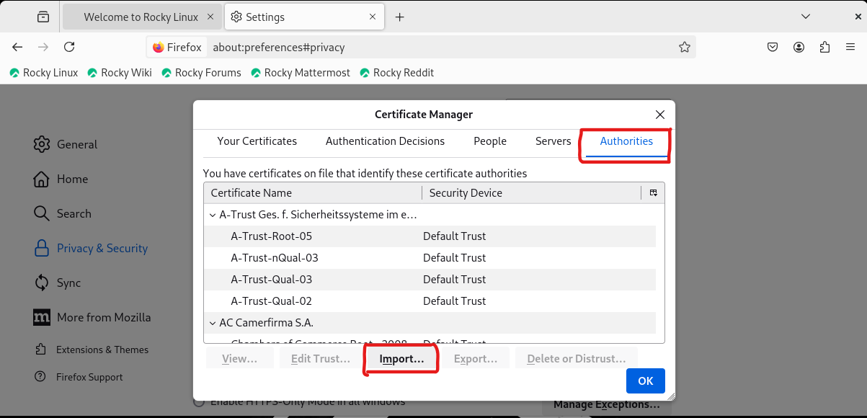

Figure 4.0.13 [Navigating to Authorities tab]

Step 13: In the newly opened panel, click on **+ Other Locations** tab on the left before browsing to the location where the CA certificate is located (**/var/nfs/ShareToClient/**). Then select the self-signed certificate before clicking the **Open** button at the top right corner.

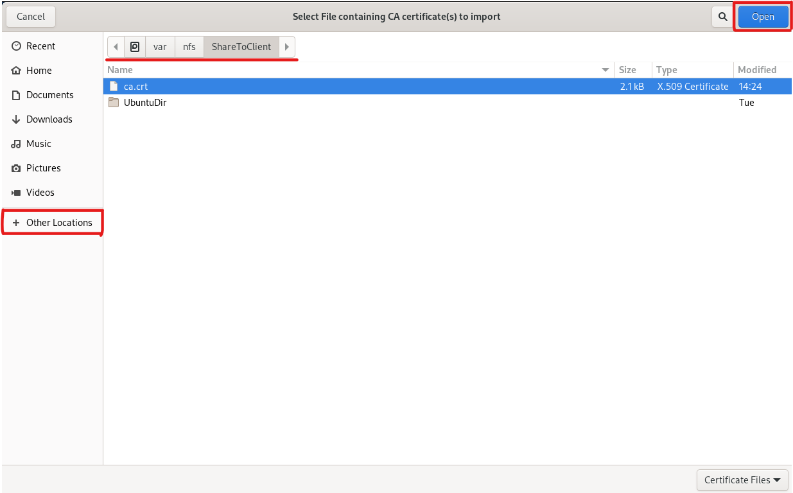

Figure 4.0.14 [Selecting the self-signed CA]

Step 14: Make sure that the checkbox is checked before clicking **OK**, so that Mozilla Firefox trusts this CA to identify websites.

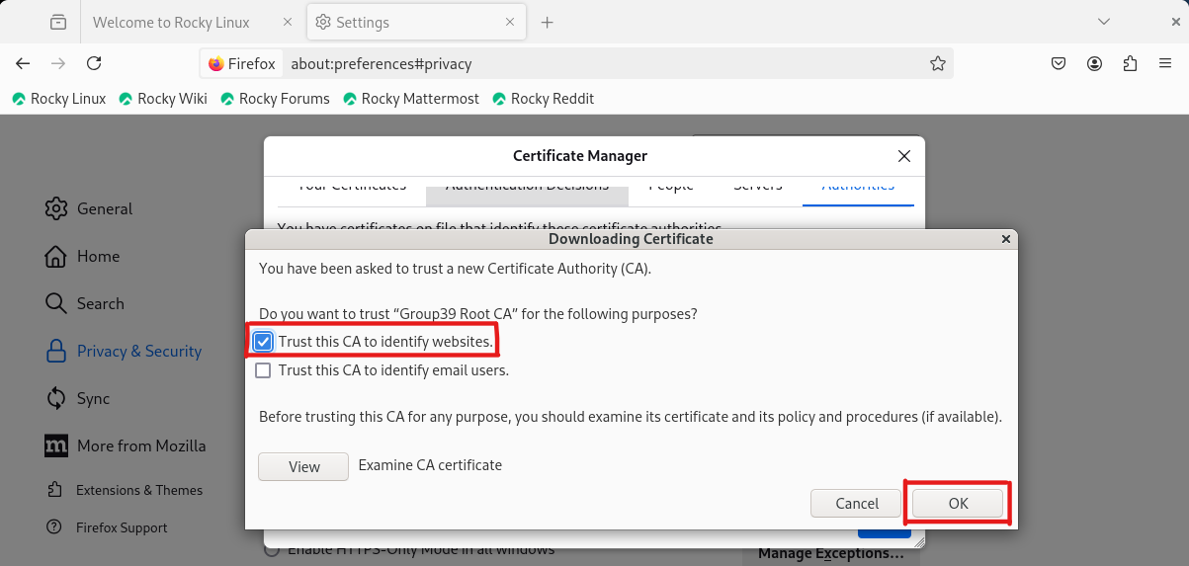

Figure 4.0.15 [Selecting CA trust purpose in Rocky Server’s Mozilla Firefox]

Step 15: Verify that **Group39 Root CA** is listed in Mozilla Firefox’s list of trusted CA before clicking **OK** and exit Mozilla Firefox.

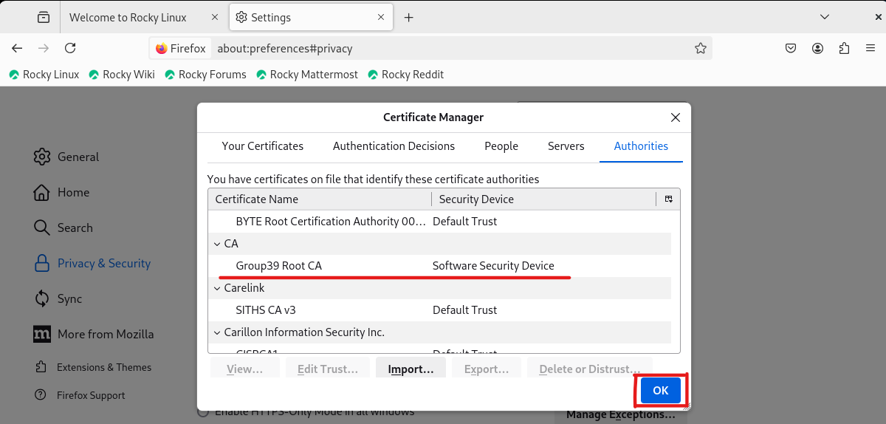

Figure 4.0.16 [Confirming existence of self-signed CA listed in trusted CA list for Rocky Server’s Mozilla Firefox]

Step 16: Open the terminal again, generate a private key for Apache web server with the command **sudo openssl genrsa -out /etc/pki/tls/private/www.group39.com.key 2048**

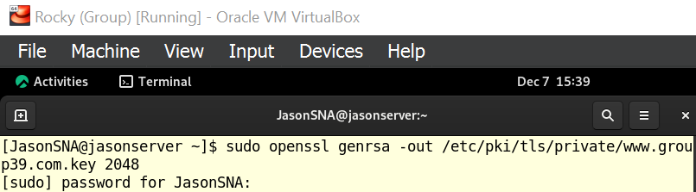

Figure 4.0.17 [Generating private key for Apache web server]

Explanation for command in Figure 4.0.17:

* **-out /etc/pki/tls/private/www.group39.com.key:**
  + Specifies the file path and file for the generated RSA private key. In this case, the private key is named **www.group39.com.key** in the directory of **/etc/pki/tls/private/**.
  + This directory is used by SSL/TLS services to store private keys.
* **2048:**
  + Specifies the size of the private key in bits.
  + Although a 2048-bit key is less secure when compared to the 4096-bit key, it is used here as it is more widely compatible and results in better performance.

Step 17: Create a Certificate Signing Request (CSR) for Apache web server using the command **sudo openssl req -new -key /etc/pki/tls/private/www.group39.com.key -out /etc/pki/tls/certs/www.group39.com.csr**.

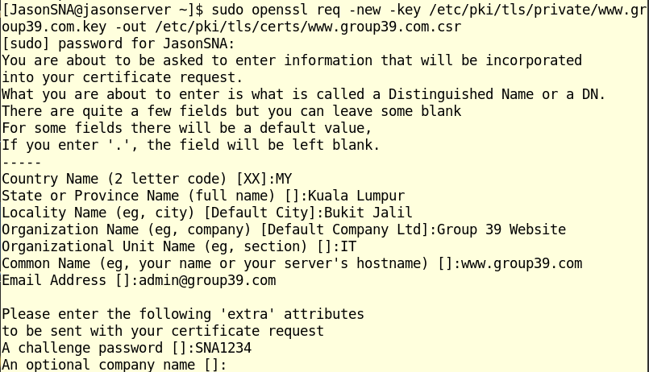

Figure 4.0.18 [Creating CSR for Apache web server]

Explanation for command in Figure 4.0.18:

* **-new -key /etc/pki/tls/private/www.group39.com.key:**
  + Creates a new CSR and specifies that the private key created in the previous step (**www.group39.com.key)** will be used to sign it, completing the CSR.
* **-out /etc/pki/tls/certs/www.group39.com.csr:**
  + Specifies the file path and file that the CSR will be saved as.
  + CSR is saved in **/etc/pki/tls/certs/** which is a standard directory for storing TLS/SSL certificates.

Step 18: Sign the CSR using **Group39 Root CA**’s self-signed certificate and private key with the command **sudo openssl x509 -req -in /etc/pki/tls/certs/www.group39.com.csr -CA /root/CA/certs/ca.crt -CAkey /root/CA/private/ca.key -CAcreateserial -out /etc/pki/tls/certs/www.group39.com.crt -days 365 -sha256**.

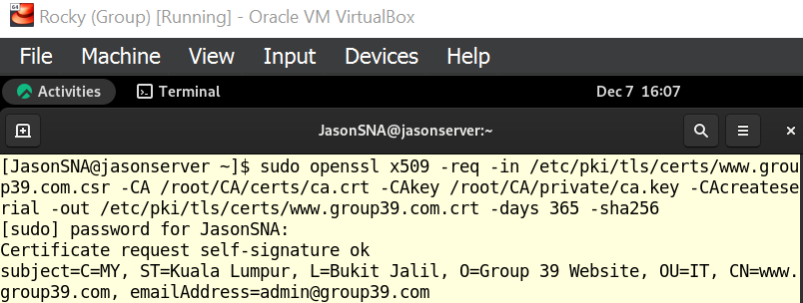

Figure 4.0.19 [Signing CSR using self-signed certificate and private key]

Step 19: With all the necessary certificates and private key ready, open Apache virtual host configuration file using the command **sudo nano /etc/httpd/conf.d/group39.com.conf**.



Figure 4.0.20 [Opening Apache virtual host configuration file]

Step 20: In the file, add the following lines to enable HTTPS protocol for **www.group39.com**.

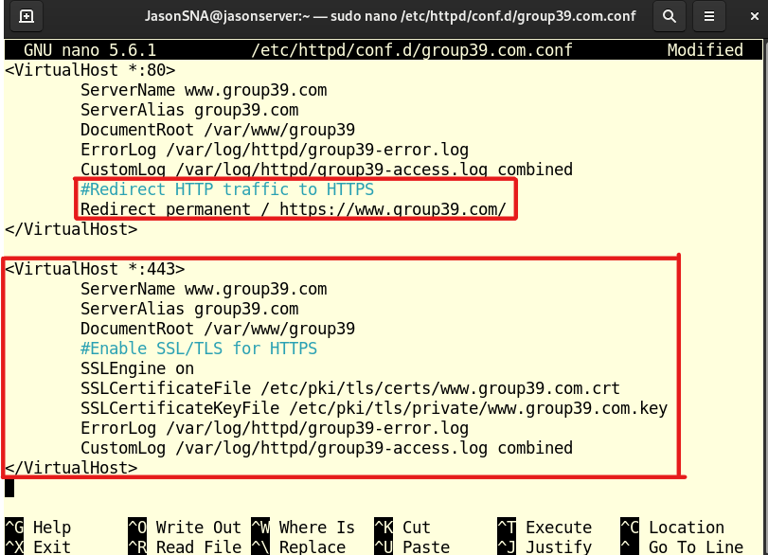

Figure 4.0.21 [Configuring Apache virtual host configuration file]

Explanation for configuration in Figure 4.0.21:

* **<VirtualHost *:80>:**
  + Configures Port 80
  + Default port for HTTP.
* **Redirect permanent /** [**https://www.group39.com/**](https://www.group39.com/)**:**
  + This line forces all requests to **http://www.group39.com** to be redirected to **https://www.group39.com.**
* **<VirtualHost *:443>:**
  + Configures Apache to listen for Port 443.
  + Default port for HTTPS.
* **ServerName www.group39.com** & **ServerAlias group39.com:**
  + Specifies the primary domain name and alternative domain name.
* **DocumentRoot /var/www/group39:**
  + Specifies the root directory of the websites’ files for Apache virtual host.
* **SSLEngine on:**
  + Enables SSL/TLS service for Apache virtual host.
  + Ensures that communication is encrypted.
* **SSLCertificateFile /etc/pki/tls/certs/www.group39.com.crt:** 
  + Specifies the location of the SSL/TLS certificate for www.group39.com that was created in Step 18.
* **SSLCertificateKeyFile /etc/pki/tls/private/www.group39.com.key:**
  + Specifies the location of the private key corresponding to the certificate. This key was generated in Step 16.
* **ErrorLog /var/log/httpd/group39.com-error.log:**
  + Specifies the file where Apache will log error messages such as missing files, misconfigurations, and SSL handshake failures.
* **CustomLog /var/log/httpd/group39.com-access.log combined:**
  + Specifies the file where Apache will log access requests which includes client IP address, requested URL, HTTP response code and user agent string.
* **</VirtualHost>:**
  + End of port configuration.

Step 21: Use the command **sudo dnf install -y mod_ssl** to install the SSL/TLS module for Apache web server to handle HTTPS connections by providing encryption via SSL/TLS protocols.

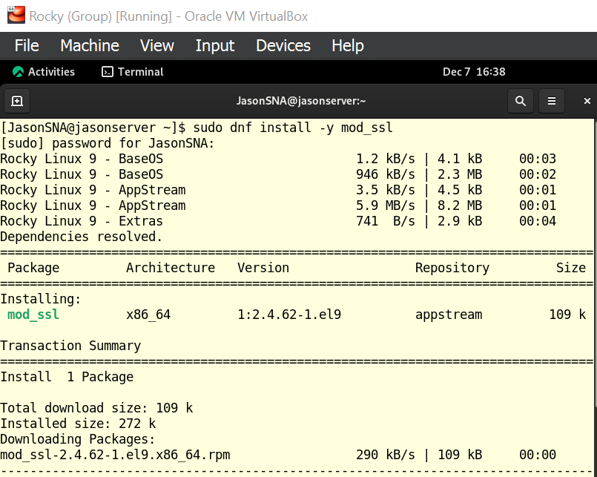

Figure 4.0.22 [Installing SSL/TLS module part 1]

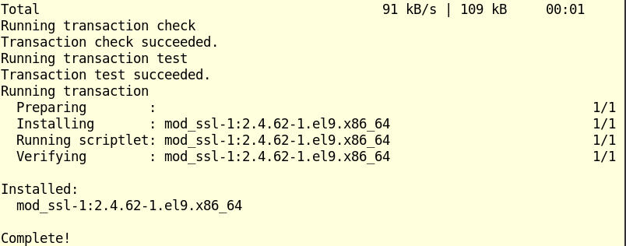

Figure 4.0.23 [Installing SSL/TLS module part 2]

Step 22: Reload Apache web server using the command **sudo systemctl reload httpd** to ensure that the latest modifications take effect.



Figure 4.0.24 [Reloading Apache web server]

Step 23: In Rocky Server, open Mozilla Firefox web browser and go to **www.group39.com**.

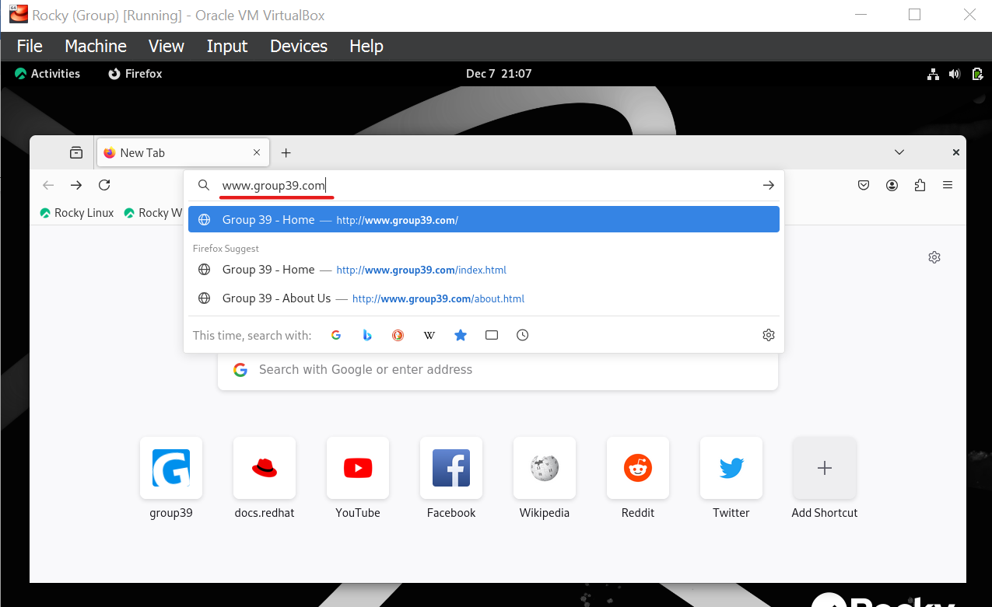

Figure 4.0.25 [Going to www.group39.com on Mozilla Firefox web browser]

Step 24: Without specifying the protocol to use, Apache web server will automatically use HTTPS protocol because of the configurations in virtual host configuration file in Step 20. However, it appears that Mozilla Firefox does not trust the website’s certificate.

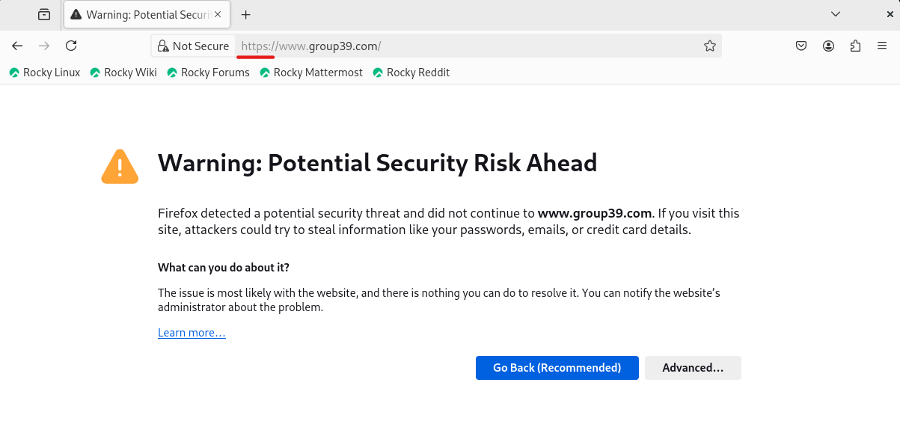

Figure 4.0.26 [Certificate not trusted by Mozilla Firefox web browser]

Step 25: Clicking on the **Advanced…** button, it shows the error code of “SSL_ERROR_BAD_CERT_DOMAIN”. This might be caused by the absence of Subject Alternative Name (SAN) during the Certificate Signing Request creation, which is required starting from version 101.0.

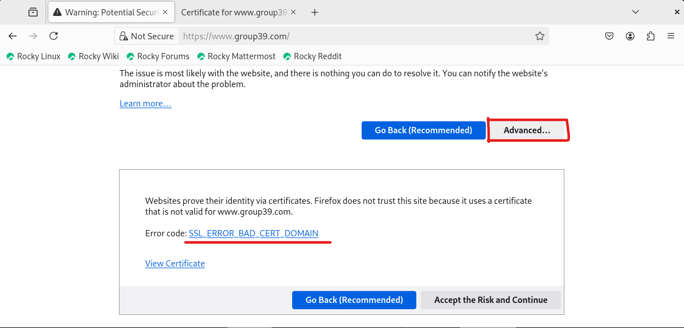

Figure 4.0.27 [SSL_ERROR_BAD_CERT_DOMAIN error code]

Step 26: Open the terminal once again and create a custom OpenSSL configuration file that will include the SAN extension using the command **sudo nano /etc/ssl/openssl-san.cnf**.

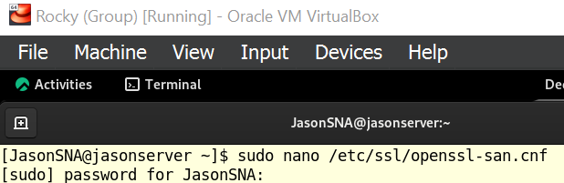

Figure 4.0.28 [Opening custom OpenSSL configuration file]

Step 27: In the custom OpenSSL configuration file, add the following lines.

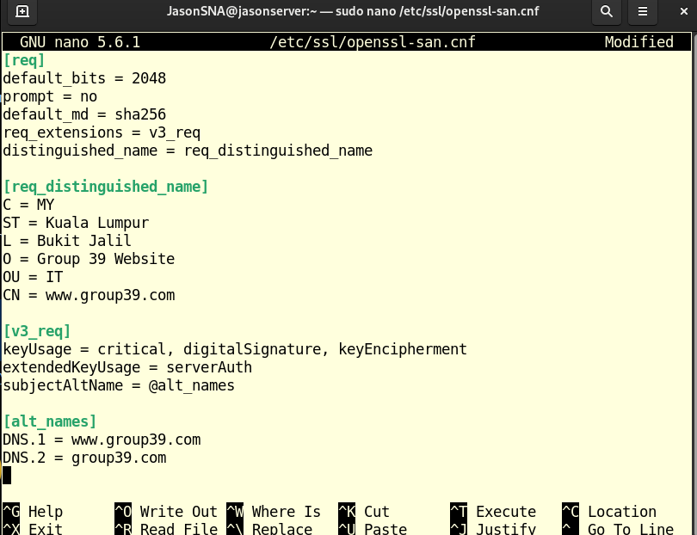

Figure 4.0.29 [Configuring custom OpenSSL configuration file]

Explanation of configuration in Figure 4.0.29:

**[req]:**

* **default_bits = 2048**
  + Specifies the key length for the RSA private key
* **prompt = no**
  + Disables interactive prompts during certificate generation
  + Automatically uses values from the configuration file
* **default_md = sha256**
  + Specifies the hashing algorithm
* **req_extensions = v3_req**
  + Defines additional extensions
  + Pointed to the section [v3_req]
* **distinguished_name = req_distinguished_name**
  + Defines the details of the certificate’s subject
  + Pointed to the section [req_distinguished_name]

**[req_distinguished_name]:**

* **C = MY**
  + Specifies the country code.
* **ST = Kuala Lumpur**
  + Specifies the State or province.
* **L = Bukit Jalil**
  + Specifies the locality, city or town.
* **O = Group 39 Website**
  + Specifies the organization name.
* **OU = IT**
  + Specifies the department in the organization
* **CN = www.group39.com** 
  + Specifies the Common Name, which is usually the FQDN.

**[v3_req]:**

* **keyUsage = critical, digitalSignature, keyEncipherment**
  + Specifies the usage of the keys
  + digitalSignature – Used to sign data for authentication
  + keyEncipherment – Used to encrypt data during TLS handshakes
* **extendedKeyUsage = serverAuth**
  + Specifies additional purposes for the certificate
  + serverAuth – Used for server authentication
* **subjectAltName = @alt_names**
  + Specifies the Subject Alternative Names (SAN) for the certificate
  + Points to [alt_names] section

**[atl_names]:**

* **DNS.1 = www.group39.com** & **DNS.2 =group39.com**
  + Allows a single certificate to secure multiple domains or subdomains.

Step 28: Recreate a new Certificate Signing Request using the custom OpenSSL configuration file and replace the old CSR by using the command **sudo openssl req -new -key /etc/pki/tls/private/www.group39.com.key -out /etc/pki/tls/certs/www.group39.com.csr -config /etc/ssl/openssl-san.cnf**.



Figure 4.0.30 [Creating new CSR using Custom OpenSSL configuration file]

Explanation of command in Figure 4.0.30:

* **-config /etc/ssl/openssl-san.cnf**
  + Ensures that the CSR is created using the custom OpenSSL configuration file located at **/etc/ssl/openssl-san.cnf**.

Step 29: Sign the new CSR with **Group39 Root CA** to generate a new certificate that includes the Subject Alternative Name and replace the old certificate using the command **sudo openssl x509 -req -in /etc/pki/tls/certs/www.group39.com.csr -CA /root/CA/certs/ca.crt -CAkey /root/CA/private/ca.key -CAcreateserial -out /etc/pki/tls/certs/www.group39.com.crt -days 365 -sha256 -extfile /etc/ssl/openssl-san.cnf -extensions v3_req**.

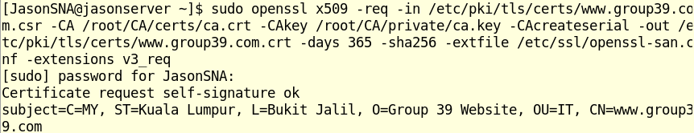

Figure 4.0.31 [Signing new CSR with Group39 Root CA]

Explanation of command in Figure 4.0.31:

* **-extfile /etc/ssl/openssl-san.cnf**
  + Specifies the custom OpenSSL configuration file to use.
* **-extensions v3_req**
  + Ensure the **v3_req** section in the custom OpenSSL configuration file is used to define the SAN.

Step 30: Verify that the new certificate for **www.group39.com** now includes SAN by running the command **sudo openssl x509 -in /etc/pki/tls/certs/www.group39.com.crt -text -noout | grep -A 1 “Subject Alternative Name”**.

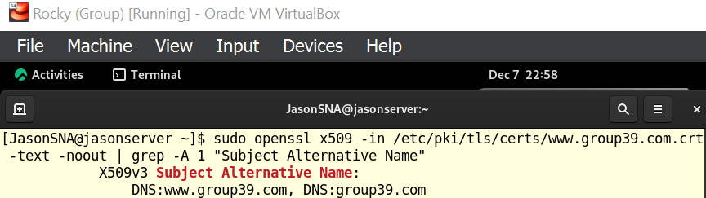

Figure 4.0.32 [Checking SAN for www.group39.com]

Step 31: Reload Apache web server with **sudo systemctl reload httpd** to ensure the latest certificate is being used.



Figure 4.0.33 [Reloading Apache web server]

Step 32: Open Mozilla Firefox and go to **www.group39.com** to verify if HTTPS connection has been established successfully.

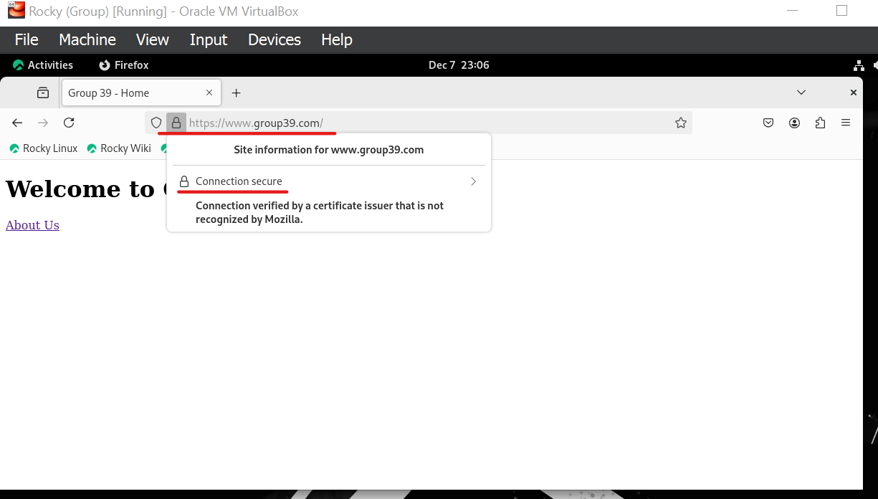

Figure 4.0.34 [Checking HTTPS connection on www.group39.com in Rocky Server’s Mozilla Firefox]

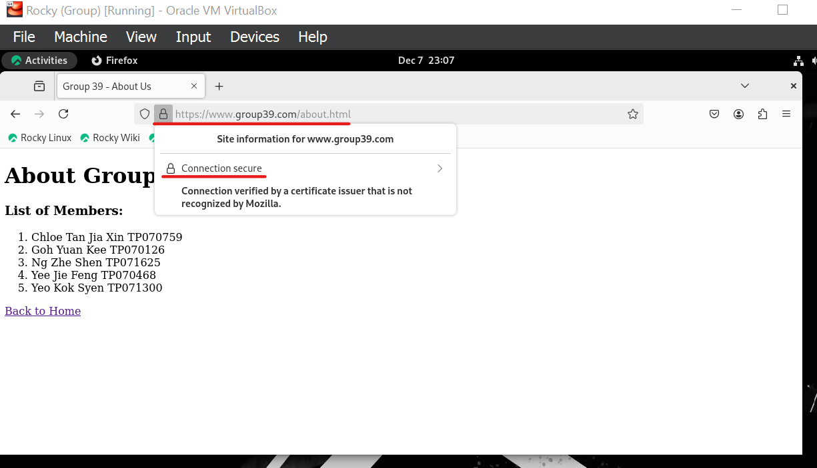

Figure 4.0.35 [Checking HTTPS connection on www.group39.com/about.html in Rocky Server’s Mozilla Firefox]

Based on the output above, it is proven that Mozilla Firefox in Rocky Server now uses **Group39 Root CA** to authenticate the certificate of **www.group39.com**, enabling secure HTTPS connection.

Step 33: Return to Ubuntu Client and open Mozilla Firefox.



Figure 4.0.36 [Opening Mozilla Firefox in Ubuntu Client]

Step 34: Repeat Step 9 – 15 (**Open application menu → Settings → Privacy & Security → Certificates → View Certificates… → Authorities → Import…**) to import the **Group39 Root CA**’s certificate into Ubuntu Client’s Mozilla Firefox list of trusted CA.

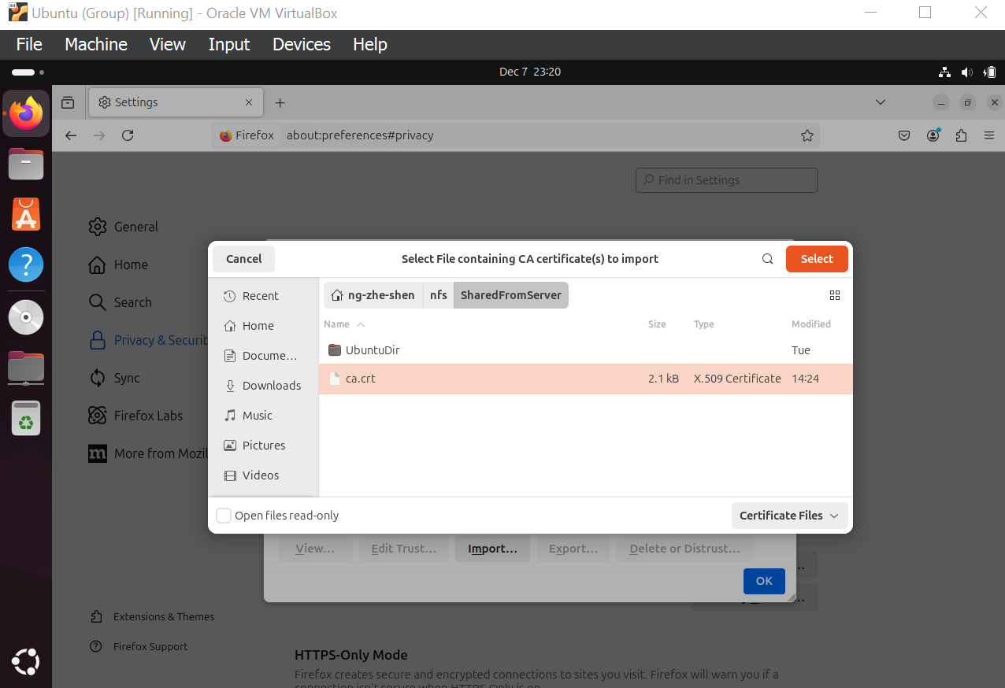

Figure 4.0.37 [Trying to import Group39 Root CA certificate into Ubuntu Client’s Mozilla Firefox trusted CA list]

Step 35: However, this operation failed, displaying error message of unable to read the contents of the shared directory – **SharedFromServer**.

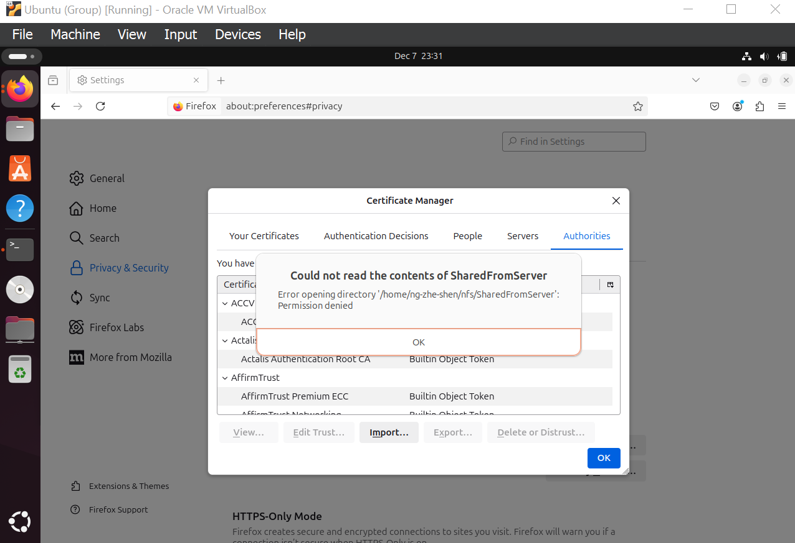

Figure 4.0.38 [Error accessing SharedFromServer from Mozilla Firefox]

Step 36: Since Mozilla Firefox couldn’t access the CA’s certificate in the NFS shared directory, open a terminal and copy the certificate to a local directory, **Downloads** in this case, using the command **sudo cp ~/nfs/SharedFromServer/ca.crt ~/Downloads/**.

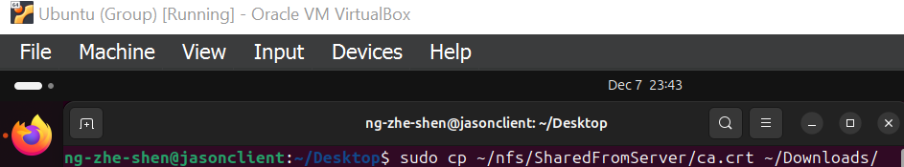

Figure 4.0.39 [Copying CA’s certificate into Downloads directory]

Step 37: Try to import **Group39 Root CA**’s certificate from the **Downloads** directory to Mozilla Firefox.

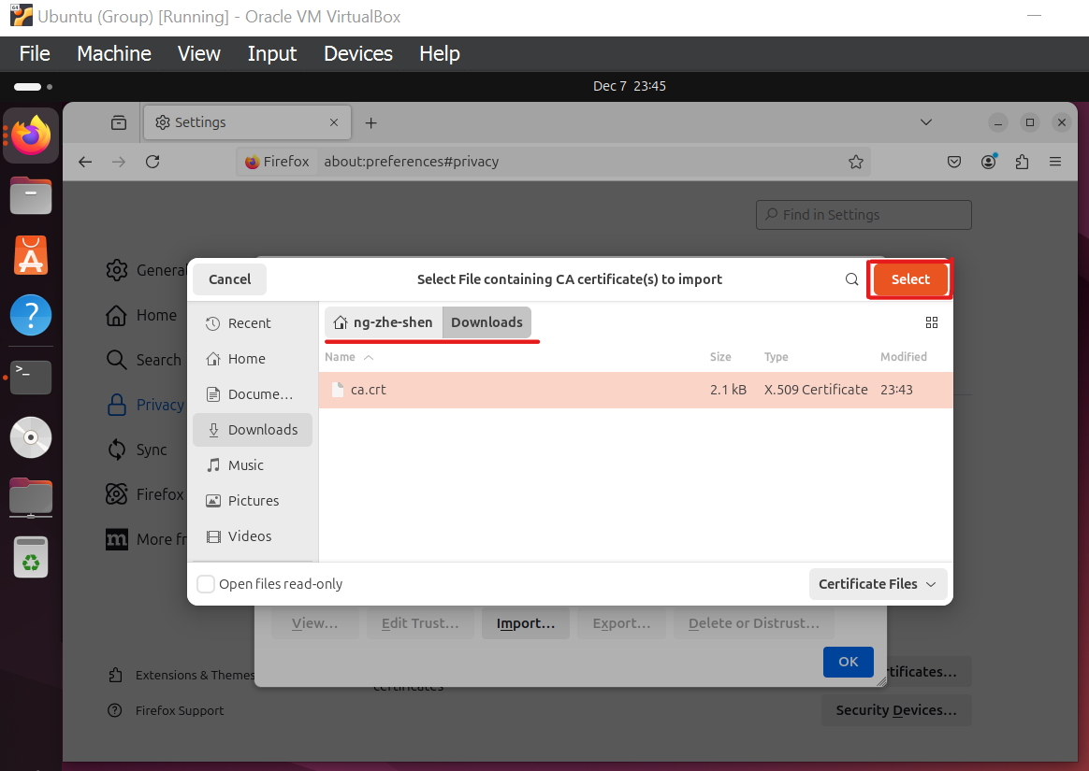

Figure 4.0.40 [Trying to import Group39 Root CA’s certificate into Ubuntu Client’s Mozilla Firefox trusted CA list from Downloads directory]

Step 38: However, due to unknown reason, this attempt failed as nothing happened on the screen after selecting the certificate to import. No error message was thrown by Mozilla Firefox, **Downloading Certificate** confirmation dialog did not appear like in Step 14, and **Group39** **Root CA**’s certificate did not appear on the list of Authorities.

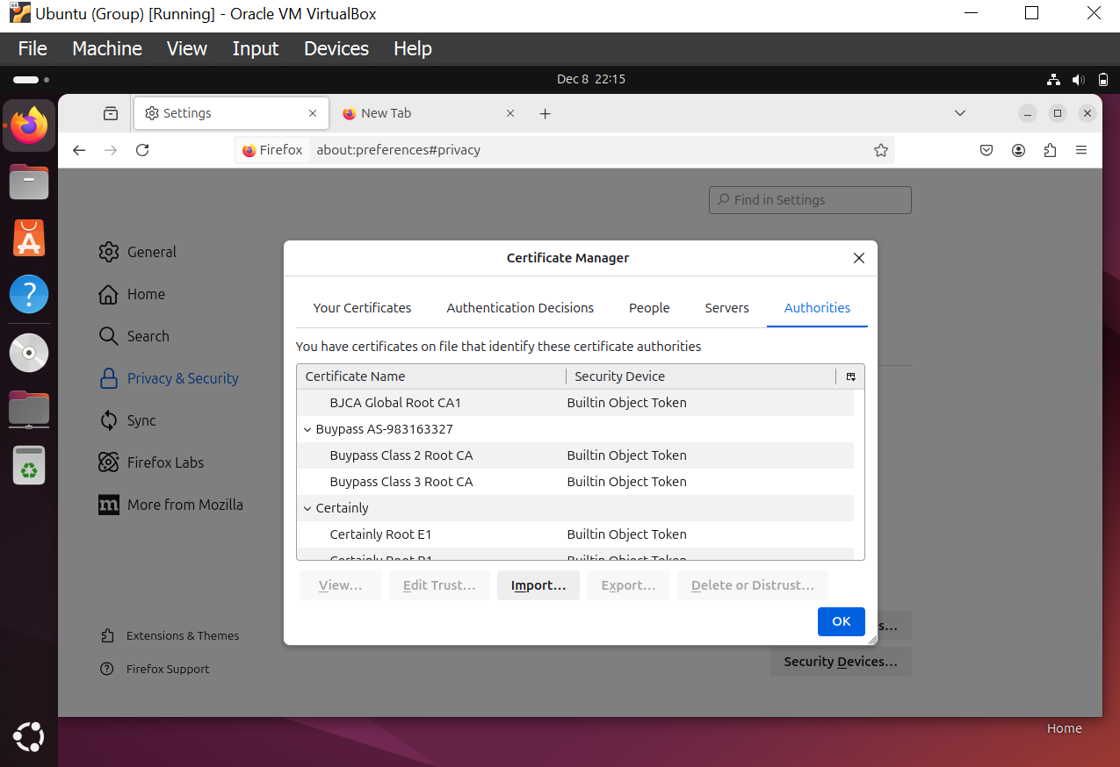

Figure 4.0.41 [Group39 Root CA’s certificate not appearing in Ubuntu Client’s Mozilla Firefox trusted CA list]

Step 39: Copy the certificate into the directory **/usr/local/share/ca-certificates/** where custom CA certificates or certificates issued by a private CA should be stored using the command sudo **cp ~/nfs/SharedFromServer/ca.crt /usr/local/share/ca-certificates/**.

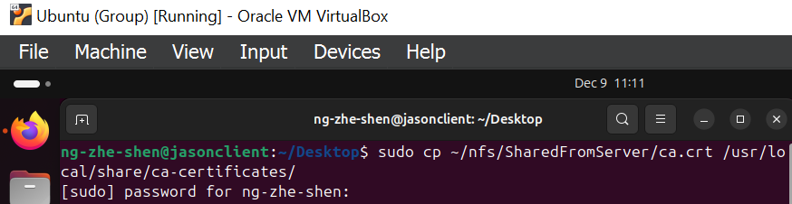

Figure 4.0.42 [Making a copy of Group39 Root CA’s certificate in /usr/local/share/ca-certificates/ directory]

Step 40: Update the system’s CA certificates store using the command **sudo update-ca-certificates**. The directory of **/usr/local/share/ca-certificates/** will be searched for certificates and added to the system’s trusted CA certificates store.

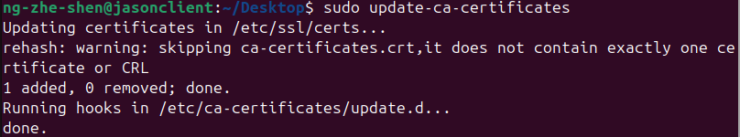

Figure 4.0.43 [Updating the system’s CA certificates store]

Step 41: Try to import **Group39 Root CA**’s certificate again but from the **/usr/local/share/ca-certificates/** directory to Mozilla Firefox.

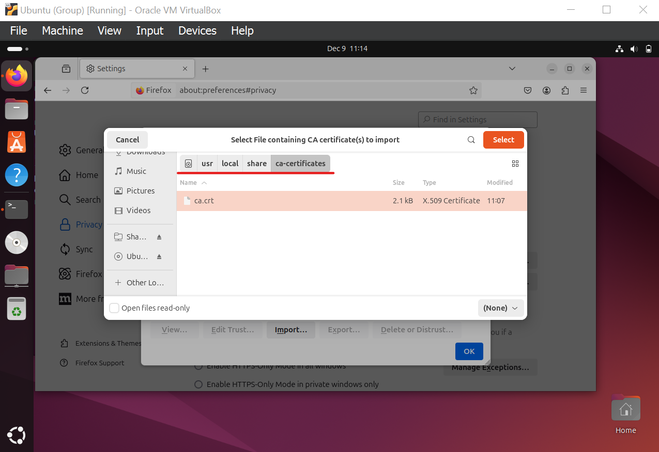

Figure 4.0.44 [Group39 Root CA’s certificate located in /usr/local/share/ca-certificates to be imported into Ubuntu Client’s Mozilla Firefox trusted CA list]

Step 42: This time a **Downloading Certificate** window pops-up. Select **Trust this CA to identify websites.** then click on **OK to confirm**.

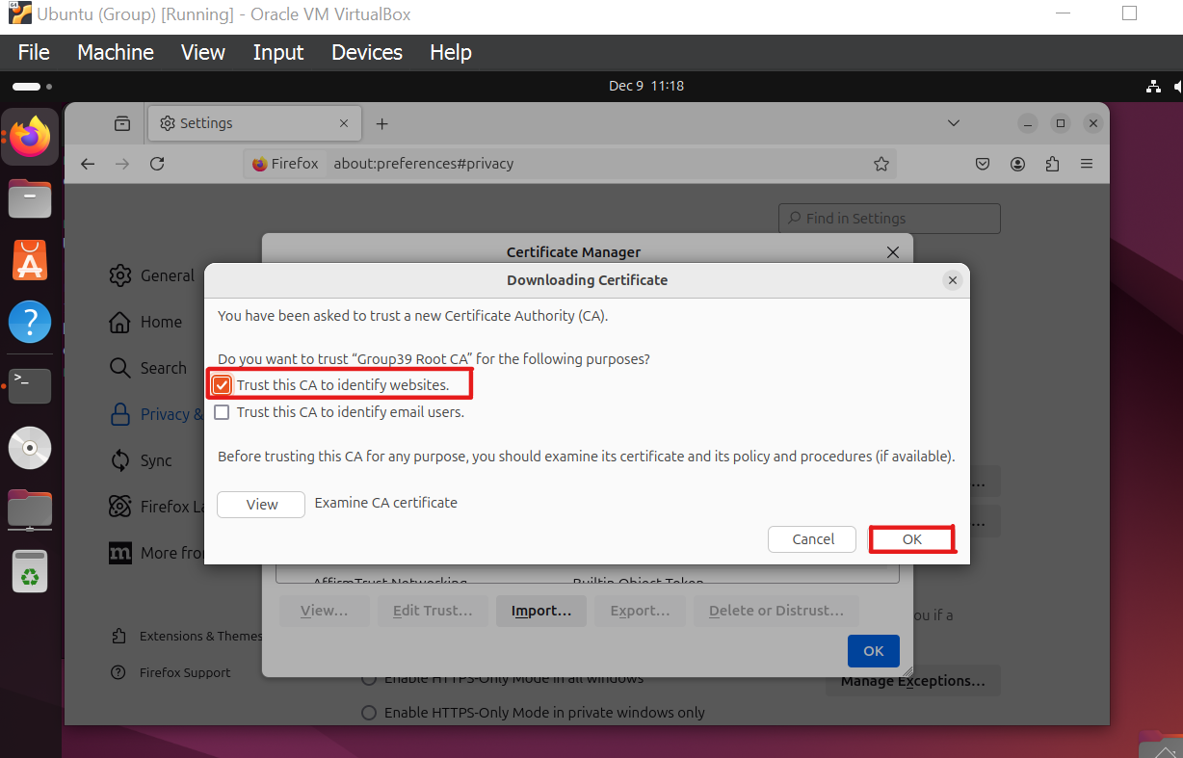

Figure 4.0.45 [Selecting CA trust purpose in Ubuntu Client’s Mozilla Firefox]

Step 43: Verify that **Group39 Root CA** is listed in Mozilla Firefox’s list of trusted CA before clicking **OK.**

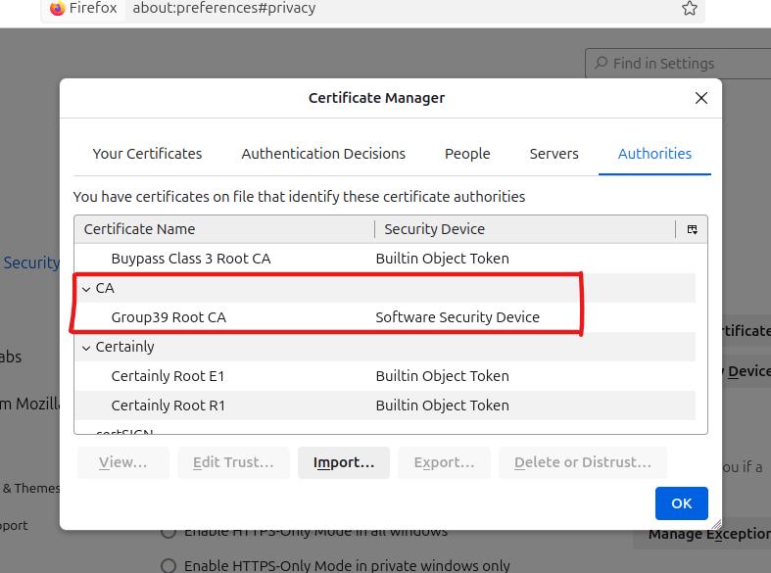

Figure 4.0.46 [Confirming existence of self-signed CA listed in trusted CA list for Ubuntu Client’s Mozilla Firefox]

Step 44: On Mozilla Firefox browser, enter the URL **www.group39.com** and **www.group39.com/about.html** to check HTTPS connection.

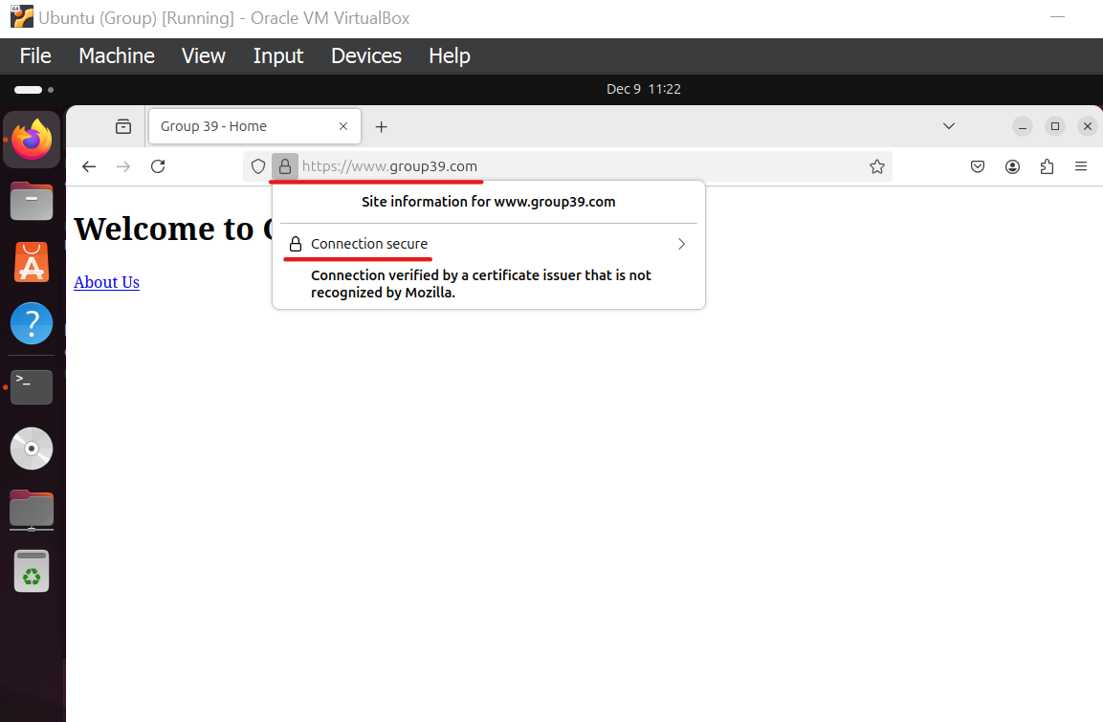

Figure 4.0.47 [Checking HTTPS connection on www.group39.com in Ubuntu Client’s Mozilla Firefox]

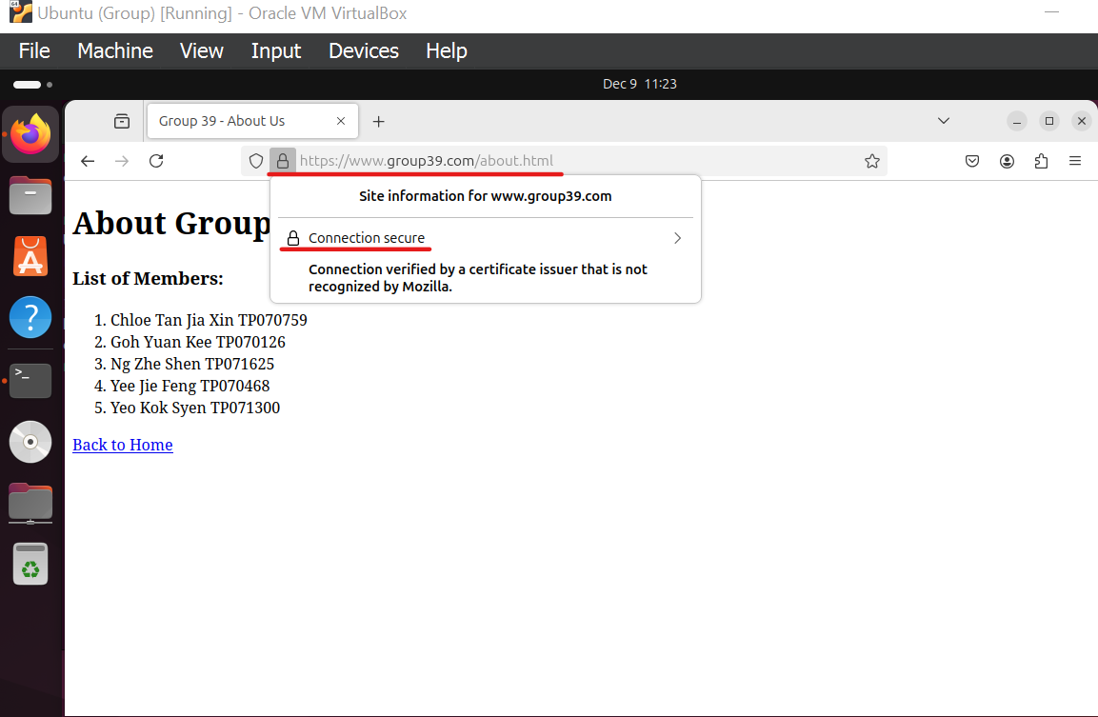

Figure 4.0.48 [Checking HTTPS connection on www.group39.com/about.html in Ubuntu Client’s Mozilla Firefox]

The output above proves that users from Ubuntu Client can now use Mozilla Firefox to establish secure HTTPS connection when browsing **www.group39.com**.

# 5.0 Additional Service

The Apache Status module is an essential monitoring tool for network administrators to monitor the Apache web server as it offers real-time information on the server’s performance. It displays detailed information on connection activity, server uptime, server processes, traffic statistics, and more. This allows for quick troubleshooting and resource optimisation to maintain high availability and reliable server operations.

Step 1: In Rocky Server, enable Apache Status by using the command **sudo nano /etc/httpd/conf/httpd.conf** and add the following lines in the Apache configuration file.

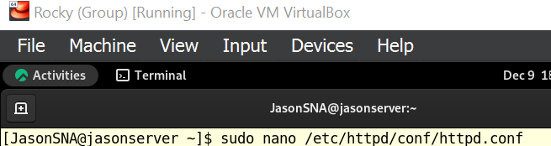

Figure 5.0.1

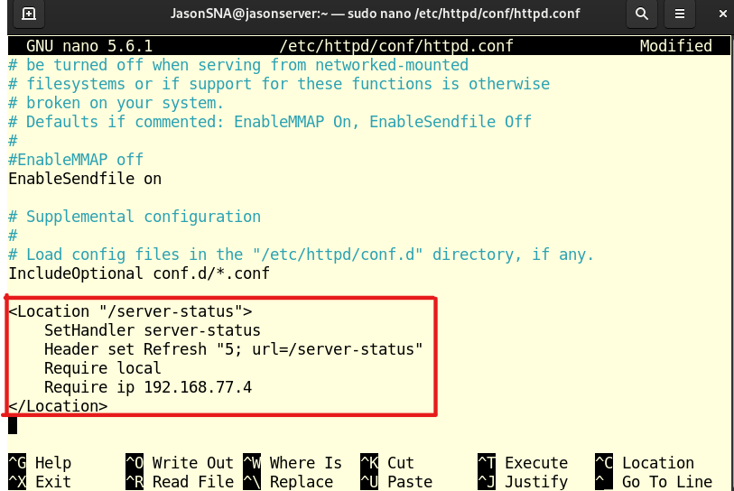

Figure 5.0.2

Figure 5.0.2 shows a few configuration lines which are:

* **<Location "/server-status">**

The location block is defined by this command. In this instance, the URL path /server-status is where the location block is defined. This indicates that only requests sent to this specific URL will be subject to the subsequent directives within this block.

* **SetHandler server-status**

This directive instructs Apache to handle requests to the /server-status URL using the server-status handler.

A built-in Apache module called the server-status handler creates a comprehensive report on the server's status, including details like the quantity of requests being processed at any given time, the overall number of requests served, the server's uptime, CPU and memory consumption, and so on.

* **Header set Refresh "5; url=/server-status"**

The /server-status URL's HTTP response now includes a Refresh header thanks to this directive. The browser is instructed by the Refresh header to automatically reload the page after a predetermined amount of time. Here, the value "5; url=/server-status" instructs the browser to refresh the page every 5 seconds, using the same /server-status URL each time. Our teammate can see real-time updates without having to manually refresh the website thanks to the dynamic view of the server status that is created by this.

* **Require local**

This directive makes sure that only requests coming from the web server itself are accessible to the server-status page. By limiting access to local connections, it helps to prevent unauthorized access to sensitive information.

* **Require ip 192.168.77.4**

This directive limits access to the server-status page to requests that are coming from a specific IP address (192.168.77.4). By doing so, this enhances security as it ensures that only authorized clients are able to access the server status.

* **</Location>**

This represents the end of the location block. It closes the specific configurations and returns to its general settings.

Step 2: Reload Apache web server with the command **sudo systemctl reload httpd**.



Figure 5.0.3

Step 3: Staying on Rocky Server, open Mozilla Firefox and go to **www.group39.com/server-status** to verify if Apache Status has been correctly configured.

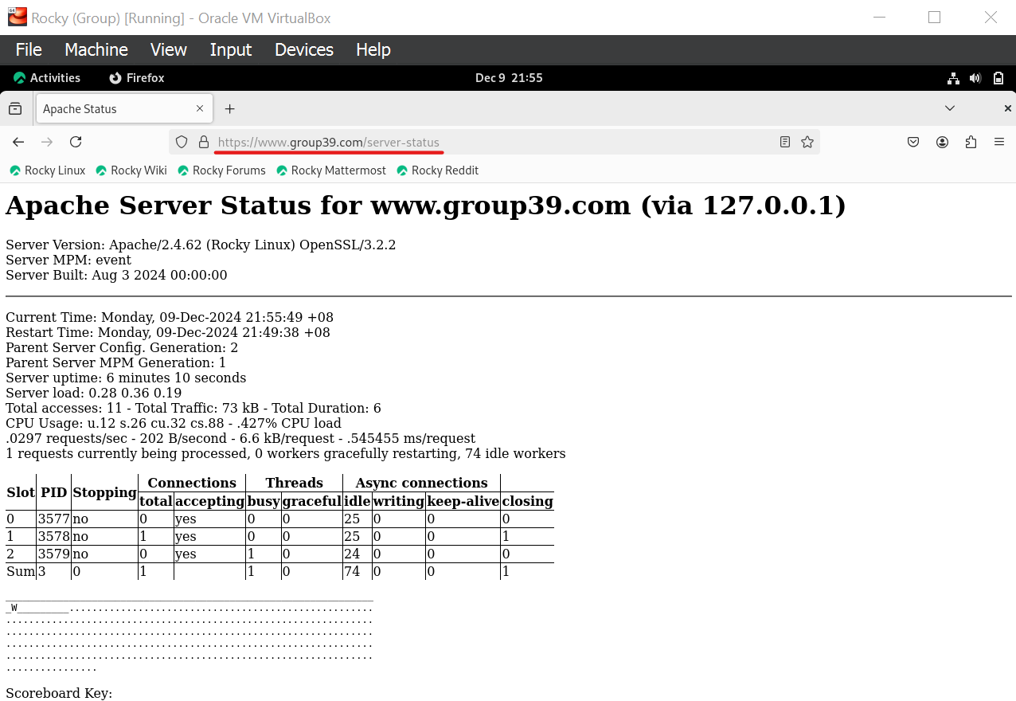

Figure 5.0.4

Based on the output above, we can see that Apache Status has been enabled and the HTML page containing the Apache web server’s information is accessible by Rocky Server.

Step 4: Boot up Ubuntu Client and try to access **www.group39.com/server-status**.

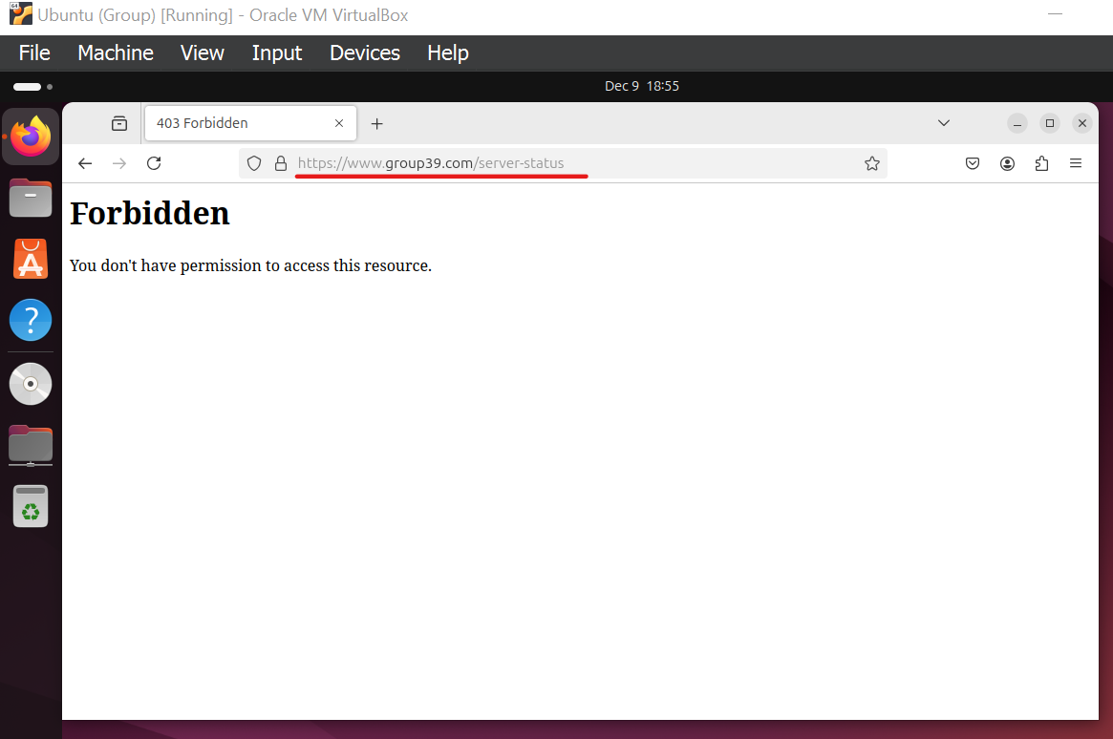

Figure 5.0.5

Looking at the outcome above, Ubuntu Client is unable to access the HTML page containing the information of Apache server. This is an expected outcome because the Apache Status module has been configured to strictly allow only incoming traffic from Rocky Server in Step 1. This is a security measure deployed to avoid sensitive information being disclosed to unauthorized Internet users.

Step 5: Going back to Rocky Server, processes related to Ubuntu Client’s action on **www.group39.com** can be seen. This proves that Apache Status is configured correctly to refresh every 5 seconds and display real-time status of the server.

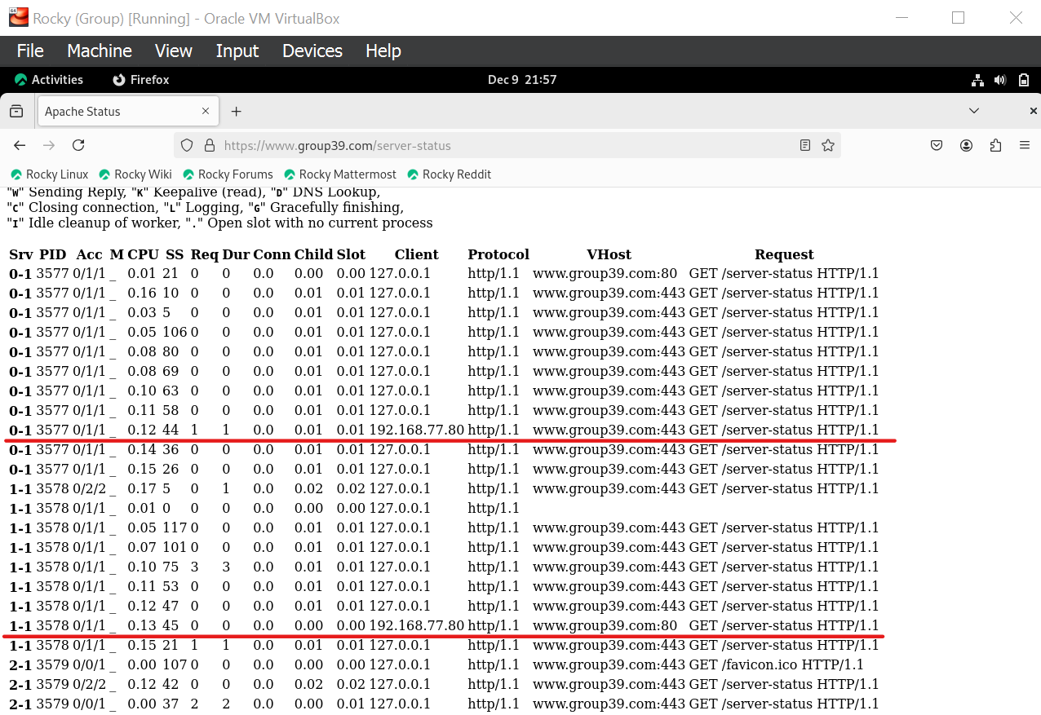

Figure 5.0.6

# 6.0 Conclusion

The robust NFS protocol centralizes resources for simpler management while simulating local file access to enable smooth file sharing across networked systems. Through caching and asynchronous writing, NFS boosts efficiency and fosters cooperation by incorporating remote resources into local settings. It is essential for small-scale networks and enterprise infrastructures needing scalable, transparent, and secure file sharing solutions because of its cross-platform compatibility and support for secure access methods.

An Apache Web Server has been configured in this project to host websites within an organization’s local network. This is a cost-effective solution for hosting local websites, as the Apache Web Server is open-source and well-known for its reliability. Additionally, this reduces the costs associated with third-party hosting services, as the organization manages its own web server. This setup serves as a reliable foundation to support internal operations and is highly scalable to accommodate future expansion.

The implementation of CA and securing the Apache web server with HTTPS are crucial steps in enhancing security and fending off malicious attacks. CA has the role of establishing trust by issuing and validating digital certificates that authenticate the website’s identity. This ensures that users are connecting to the genuine website instead of a fake website used in website phishing. Other threats such as MITM attacks are also mitigated as communication between server and client is encrypted with HTTPS protocol. The successful transition to HTTPS ensures a secure and reliable browsing experience for users.

Setting up the Apache Status module is a crucial step for network administrators seeking to efficiently manage web server performance. Using the specified steps such as modifying the Apache configuration that limits the access to authorized users, the administrators can enhance security while enabling real-time insights into server operations. Through ensuring prompt troubleshooting and well-informed decision-making, it increases server efficiency and dependability. The solution preserves operational openness while protecting vital information by setting up secure access constraints to sensitive data, such as limiting the accessibility of Apache Status to certain unauthorized IP addresses.

In a nutshell, this documentation acts as a detailed guide for amateur Rocky and Ubuntu Linux users to set up a fully functional Apache web server suitable for small-scaled organizations.

# 7.0 Workload Matrix

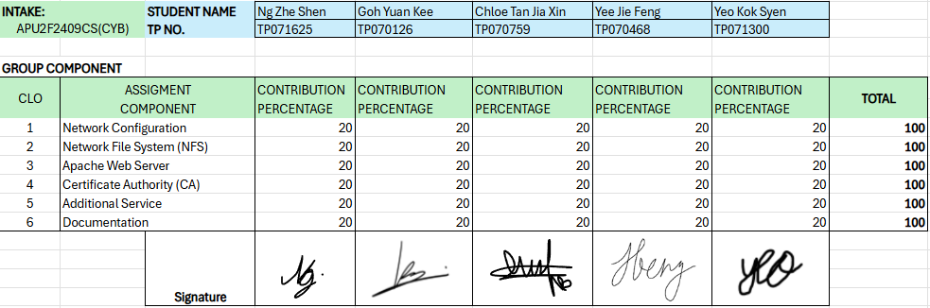

# 8.0 References

Apache. (n.d.). *Apache Virtual Host documentation*. <https://httpd.apache.org/docs/2.4/vhosts/#:~:text=Versions%201.1%20and%20later%20of,or%20non%2DIP%20virtual%20hosts>.

Domantas, G. (2024, February 22). *What Is Apache Web Server and How Does It Work*. <https://www.hostinger.com/tutorials/what-is-apache>

GeeksforGeeks. (2023, February 6). *Network File System (NFS)*. GeeksforGeeks. <https://www.geeksforgeeks.org/network-file-system-nfs/>

Gomez, J. (2023, March 17). How to install Apache on Rocky Linux 9 | LinuxTeck. *LinuxTeck*. <https://www.linuxteck.com/how-to-install-apache-on-rocky-linux/>

Hernandez, J. (2019, May 8). *What is Apache? In-Depth Overview of Apache Web Server*. <https://www.sumologic.com/blog/apache-web-server-introduction/>

*How To Create a Self-Signed SSL Certificate for Apache on CentOS 8 | DigitalOcean*. (n.d.). <https://www.digitalocean.com/community/tutorials/how-to-create-a-self-signed-ssl-certificate-for-apache-on-centos-8>

Kiarie, J., & Kiarie, J. (2020, September 28). *How to Monitor Apache Performance Using mod_status in Ubuntu*. How To Monitor Apache Performance Using Mod_Status in Ubuntu. <https://www.tecmint.com/ubuntu-apache-mod_status/>

King, A. (2023, April 27). *Using OpenSSL to create certificate signing request with Subject Alternative Names*. Cybersylum. <https://www.cybersylum.com/2022/02/28/using-openssl-to-create-certificate-signing-request-with-subject-alternative-names/>

Loshin, P. (2022, April 14). *Network File System (NFS)*. Search Enterprise Desktop. <https://www.techtarget.com/searchenterprisedesktop/definition/Network-File-System>

Mervana, P. (2024, March 2). *How to Install an SSL Certificate on Apache*. SSLInsights. <https://sslinsights.com/how-to-install-ssl-certificate-on-apache/>

Sah, J. (2024, December 3). *How to Install Apache Webserver on Rocky Linux 9*. Vultr Docs. <https://docs.vultr.com/how-to-install-apache-webserver-on-rocky-linux-9>

Tamang, P. L. (2023, November 28). Configuring a Self-Signed SSL Certificate on a Apache Server. *Medium*. <https://medium.com/@pasanglamatamang/configuring-a-self-signed-ssl-certificate-on-a-apache-server-cbcd6eefdf1a>